CCU of SC
FACULTY HANDBOOK
IMPLEMENTED AND EFFECTIVE DATE__2024-2028

Revised August 27, 2025

CCU of SC Mission is to equip and empower the body of Christ to do the work of the ministry and to advance the Kingdom of God. To provide biblical education and training that promotes spiritual growth and maturity and empowers believers to live successful and victorious lives in Jesus Christ.


CENTRAL CHRISTIAN UNIVERSITY OF SOUTH CAROLINA
FACULTY HANDBOOK
TABLE OF CONTENTS
Greetings from The CCU Vice President………………….…………………………………….….….…..i
Greetings from The Chairperson of the Faculty…………………………………………………….….….ii
History…………………………………………………………………………………………………….iii
About the Faculty Handbook………………………………………………………………………………1
Mission...………………………………………………………………………….. ……………..1
Statement of Recruitment, Appointment, or Promotion……………………………………….....2
Statement of Teaching Loads…………………………………………………………………..…4
Statement of Intellectual Property Rights……………………………………………………..….4
Statement of Academic Freedom……………………………………………………………..…..5
Personnel Records……………………………………………………………….………………..6
Faculty Roles, Rights in Governance……………………………………… ………………….…7
Faculty Responsibilities……………………………………………………………………….…..8
Administration Structure / CCU of SC Administration……………………………………….…10
Duties of the Administration……………………………………………………………………..11
CCU of SC Grade Scale ………………………………………………………………………....12
Faculty and Student/ Related Policies………………………………………..…………………..13
Student Services ………………………………………………………………………………....14
Student Information……………………………………………………………………………...15
Special Needs and Disability…………………………………………………………………….16
Student Complaint……………………………………………………………………………….16
Final Exam Course Grade………………………………………………………………………..16
Exams for Online Courses……………………………………………………………………….17
Faculty Protocol………………………………………………………………………………….18
Faculty Benefits………………………………………………………………………………….19
Faculty Policy…..………………………………………………………………………………..19
Inclement Weather Policy………………………………………………………………………..20
Appendix 001, 002, and 003……………………………………………………………………..21
From the Vice President of Institutional Advancement

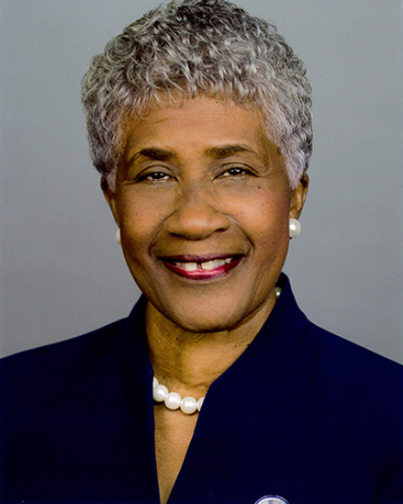

Greetings, Central Christian University of South Carolina Faculty,
It is more than a pleasure; it is a privilege to welcome you to our prestigious university. There is no university in South Carolina that is solely dedicated to “equip and empower the Body of Christ to do the work of the ministry and to advance the Kingdom of God; to provide biblical education and training that promotes spiritual growth and maturity. and empower believers to live victorious lives in Jesus Christ.”
Your acceptance to become an intricate part of our tremendous efforts speaks volumes of your love for Christ and your willingness to serve HIM and mankind through your delivery of instruction and commitment to training others to pick up the torch of enlightenment for soul-saving. Therefore, without making you feel intimidated or negatively judged, we stand ready to assist you and support you in your righteous endeavors whenever you deem it necessary.
Please accept our humble yet resounding WELCOME to the faculty of CCU of SC. This handbook is hopefully a guide to help you become more familiar with the CCU of SC Community, to assist you with Conflicts of interest, the Statement of Intellectual Property Rights, and the Statement of Academic Freedom. Because you have accepted us, we feel confident that our high expectations are in alignment with your concurred expectations. For those attributes, we give God glory and pray that your success is inevitable.
May blessing follow you always,
Mary O. Stover, Ph.D.
Dr. Mary O. Stover, Academic Dean i
From the Chairperson of the Faculty Committee

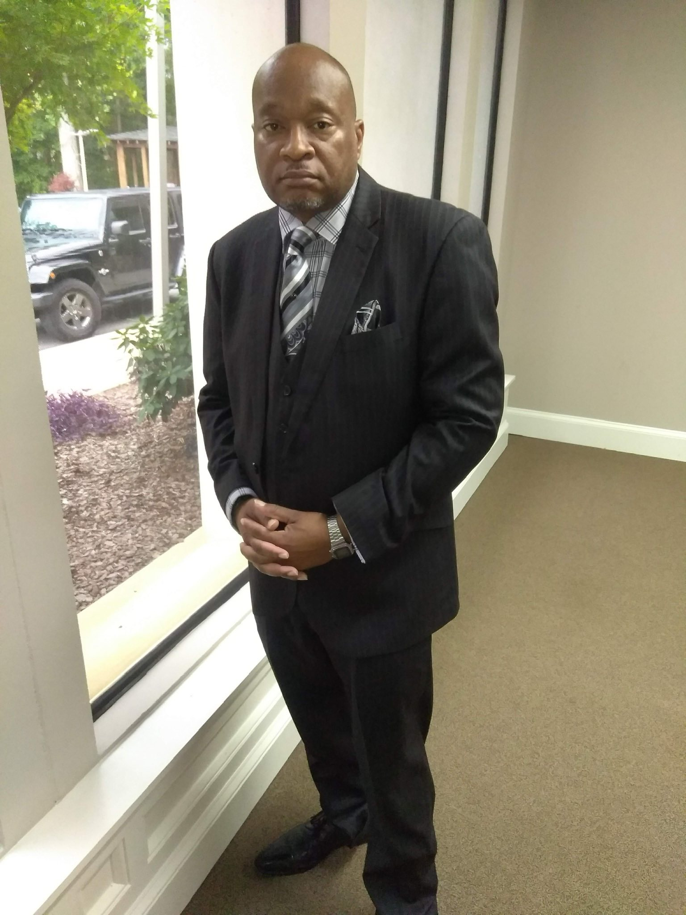

October 16, 2025
Greetings!
As the Chairman of the Faculty Committee at Central Christian University of South Carolina, Inc., it is with great honor and profound privilege that I extend my heartfelt greetings to you.
Central Christian University of SC stands as a shining beacon of hope and enlightenment within our vibrant community and its surrounding areas. We embody our sacred mission to make disciples for the Kingdom, as beautifully mandated in the Gospel of Matthew 28:19-20.
“Go therefore and make disciples of all nations, baptizing them in the name of the Father, the Son, and the Holy Spirit, and lo, I am with you always, even to the end of the age.”
This divine calling ignites our passion and inspires us daily. In the spirit of fellowship and unity, we extend our warmest greetings to you, enveloped in the love and grace of the Father, the Son, and the Holy Spirit. Let us lift each other, fostering an atmosphere filled with positivity and encouragement, as we collectively strive to fulfill our mission of discipleship and service.

May you be continuously blessed on this journey!
Dr. Daryl M. Hayes
Rev. Dr. Daryl M. Hayes, Chairman of the Faculty Committee
ii
CENTRAL CHRISTIAN UNIVERSITY OF SOUTH CAROLINA, Inc.
HISTORY

In Mims, Florida, on July 15, 1978, with much prayer and consultation, the C. E. Graham Baptist Bible Institute and Family and Pastoral Counseling Center were founded by Reverend Dr. Charles E. Graham, Pastor of the Greater St. James Baptist Church, Mims, Florida. It was operated for six years as an extension of faith, Evangelist, Christian Bible College in Morgantown, Kentucky, and The National Christian Counselors Association (NCCA) in Sarasota, Florida.

The compelling need for such an opportunity became a challenge for Dr. Graham when he, a young pastor at the age of 37 years, discovered that his congregation was in need of deacons. Upon asking a bright young man who appeared to possess a hunger for spiritual knowledge to consider training to become a deacon, Dr. Graham was confronted with the weakness that most Black people in that area silently and secretly carried. This young man could not read or write. He desired to study and train; therefore, he asked Dr. Graham to teach him to read and to write.

In concern for the dignity of the young man and at the admonition of the Holy Spirit, Dr. Graham consented to teach the rising deacon if he would carry Dr. Graham to lunch. The deal was sealed with a handshake.

As Dr. Graham began the work that had been preconditioned, other preachers and lay workers in other churches, who had been recycling sermons from others and themselves because they also could not read and write, began to seek out this young “teacher-preacher” to teach them. These spiritual soldiers no longer wanted to preach “hearsay sermons.” They desperately wanted to read the Word and have the Word speak to them so that God’s wisdom would abound. They wanted to be independent biblical scholars who created their sermons as the Holy Spirit prompted them. They wanted to interact with each other and articulate the gifts given to them by the Holy Spirit. They became a cohesive, interdependent, yet individual group of learners. The fire had been ignited that could only be quenched by Knowledge, Wisdom, and Application.

After six years of operating as a Bible Institute and Family and Pastoral Counseling Center, a need was seen for the addition of a Bible College and Theological Seminary. On May 1, 1986, an amendment was made changing the scope of the Bible Institute and Counseling Center to the C. E. Graham Baptist Bible Institute/College/Seminary, still operating as an Extension of Faith Evangelistic Schools. In August 1988, Faith Evangelistic Schools was transferred to the leadership of Dr. Michael A. Smith due to the illness and death of Dr. James Bishop, the Founder of Faith Evangelistic Schools. After much prayer, another amendment was made to the Constitution to become an independent school and to be chartered in the State of South Carolina. In May 1993, the C. E. Graham Baptist Bible Institute/College/Seminary was chartered by the State of South Carolina as a non-profit Corporation, operating at 4916 Fairfield Road, Columbia, SC. It became an independent school affiliated with Faith Baptist College and Seminary, Church Point, Louisiana, as a Satellite school with full accreditation from the American Federation of Christian Colleges and Schools and became a full member of the National Christian Counselors Association (NCCA), one of the largest associations of Christian Counselors in the world, headquartered in Sarasota, Florida.

iii

The school also made a request to the South Carolina Commission on Higher Education to be exempt from the State Licensure requirements, offering studies leading to degrees in the areas of Bible, Theology, Counseling, Church Leadership, and Christian Education. On October 11, 1994, exempt status was granted clearance using degree titles such as Associate of …, Bachelor of …, Master .., and Doctor of Theology, etc., which clearly label such degrees as professional.

On June 10, 2001, the school made another amendment to its bylaws to change its operational name to the C. E. Graham Bible Schools, Inc., because of the attraction of a wide variety of denominational backgrounds. On January 3, 2007, the School was chartered as Central Christian University of South Carolina, Inc.

To this date, Central Christian University of SC, Inc. is independent, liberal, and local church-oriented, meeting a neglected need in the field of Christian Education, Counseling, and Ministry. The University is missionary, both in belief and practice. Both Undergraduate Programs, Certificates, and Diplomas are offered. Central Christian University of South Carolina, Inc. was accredited with Transworld Accreditation until 2013. As the University has continued to prosper, Dr. Graham and the Board of Directors decided to increase the prestige and the appeal of the University by applying for accreditation with The Association for Biblical Higher Education (ABHE).

In February 2018, the ABHE Commission on Accreditation awarded Central Christian University of South Carolina, Inc. “Applicant Status.” The University endeavors to complete this journey towards full accreditation with the Association for Biblical Higher Education with committed diligence.

Currently, CCU of SC holds “Candidate Status” with the Association for Biblical Higher Education Commission on Accreditation (5850 T.G. Lee Blvd., Ste. 130, Orlando, FL 32822). Candidate Status is a pre-accreditation status granted to those institutions that meet the ABHE Conditions of Eligibility and that possess such qualities as may provide a basis for achieving accreditation status within five years. In 2023, the Council for Higher Education Accreditation (CHEA) recognized CCU of SC as a member to receive national information.
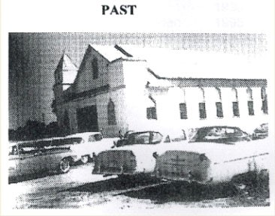
Historical picture of Greater St. James Missionary Baptist Church, Mims, Florida, Founded 1904

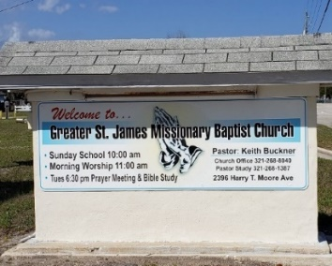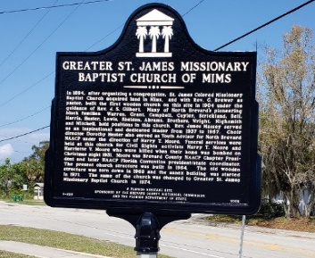


The C.E. Graham Library
The New Geographical Location of Central Christian University of South Carolina

On August 22, 2023, Central Christian University of South Carolina applied for a Substantive Geographical Change to Belmont Baptist Church, 901 Mason Road, Columbia, SC 29203, with the Association of Biblical Higher Education.

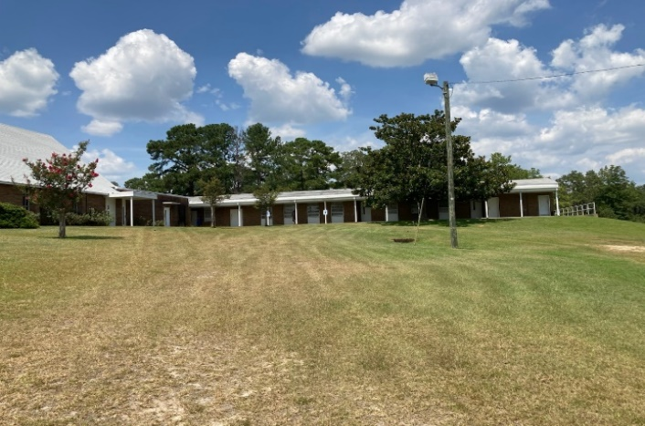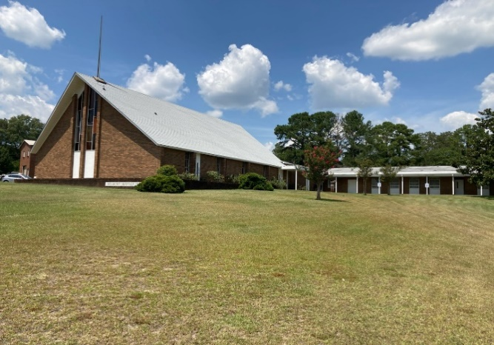

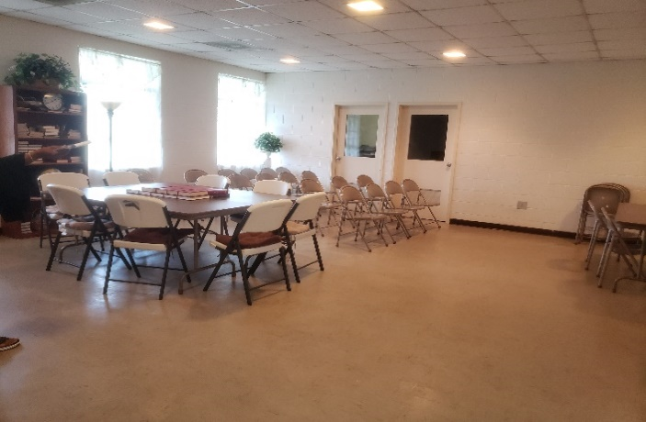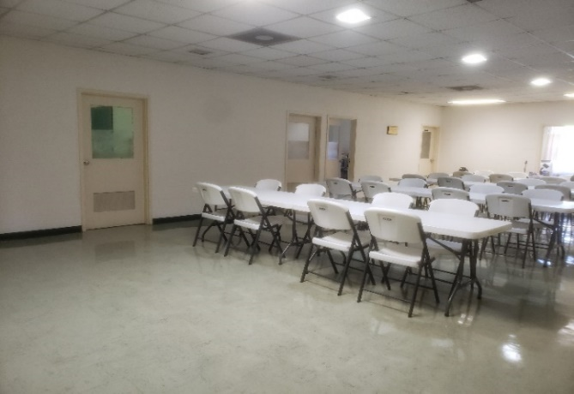

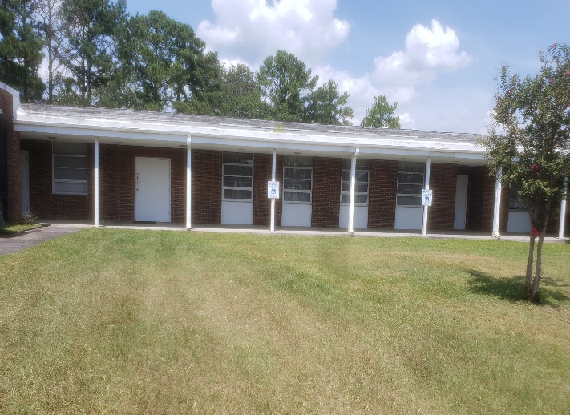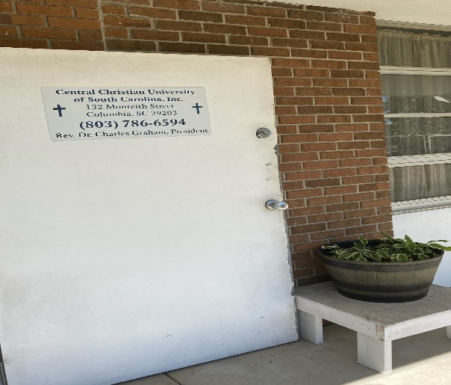

Mission Statement of Central Christian University of SC, Inc.

Central Christian University of S.C., Inc. is a multi-ethnic community dedicated to the preparation of men and women for manifold ministries to Christ and His Church.

Under the authority of the Holy Spirit and the Scriptures, we seek to fulfill our commitment to ministry education, preparation, and spiritual formation. CCU of SC, Inc., strives for excellence in all its ministries in the service of Jesus Christ under the guidance and power of the Holy Spirit and Holy Spirit-filled men and women who have been trained in the field of education and ministry.

Mission Statement-

“…is to equip and empower the body of Christ to do the work of the ministry and to advance the kingdom of God. To provide biblical education and training that promotes spiritual growth and maturity and empowers believers to live successful and victorious lives in Jesus Christ.”

Under the expert leadership of the Holy Spirit and men and women called and equipped in Christian education, Central Christian University of S.C., Inc., has continued to grow through the years and has become a leader in the implementation of higher education by the development of new programs to meet the needs of the church and the Christian community around the world.

From a rich heritage of ministry spanning one generation, God has established an educational organization of integrity and power for implementing God's purposes on earth. With a firm foundation in post-secondary Christian education, Central Christian University of S.C., Inc. has become a strategic hub for Christian leadership and Ministry.

About the Faculty Handbook
CCU of SC faculty handbook provides information to faculty members regarding the University's organizational structure, position descriptions, and operating procedures through the issuance and maintenance of the Faculty Handbook and Policies. This handbook will be updated and revised as needed, and a thorough review will be completed every five years by the Self-Study Committee. The University’s Faculty Handbook informs the faculty of policies and procedures that are the governance documents for the university’s faculty operation. The Faculty Handbook documents the commitment, procedures, regulations, and expectations of the faculty academic service to students and colleagues, the administration, and the community. While academic policies and procedures are informative, they do not encourage a disregard for the University’s Employment Policy and Procedure Manual, which is the authority on employment regulations, commitments, and expectations of Central Christian University regulations.
A Policy Manual, handbooks, and publications have been created for the promotion and implications of effective standards and operating procedures. Each administration unit is accountable for ensuring the conduct of business according to the procedures outlined for its departments. Departments are also responsible for developing, reviewing, evaluating, adding, and updating manuals on an ongoing basis to be presented to the Executive Cabin and, respectively, to the Board of Directors. 1
This handbook reflects current procedures, but in the event of a conflict, the statements contained in the current CCU of SC catalog, handbooks, policy manuals, or the Board of Directors’ official minutes and manual of rules, bylaws, and guidelines will prevail.
Please read carefully the handbook that governs professional conduct and relations in our academic community. The Central Christian University of S.C., Inc.
The Education Faculty Handbook is available at our website: www.ccuofsc.org, or write to us at Central Christian University of South Carolina-901 Mason Road, Columbia, S.C. 29203, or call us at 803-786-6594.
Administration in Relation to Faculty
Statement of Recruitment, Appointment, Promotion, or Termination of Faculty

Faculty Recruitment
Policy: When a position is declared open by the Academic Dean, a committee comprised of the Dean of Faculty and the appropriate Director (undergraduate or graduate) shall initiate the Recruitment process.
Procedures:
- The Academic Dean declares a position is open to the Dean of Faculty and the Dean of Curriculum.
- The Dean of Faculty instructs the appropriate program faculty to assist with the recruitment of potential faculty. Persons interested in the position must submit a Letter of Application, Curriculum vitae, Unofficial Transcripts, and References.
- The Dean of Faculty seeks suggestions from the faculty as well as other sources appropriate to the teaching field (e.g., institutions of similar size and scope).
- Institutional personnel review names submitted and request materials not available from potential candidates (materials listed in #2).
- The Dean of Faculty convenes the recruitment committee (comprised of the Dean of Curriculum, Dean of Faculty, and a student representative) to review the names received.
- The Recruitment Committee places the potential faculty in priority order.
- The top three faculty applicant folders are forwarded to the Dean of Faculty for review and to ensure that qualifications are appropriate for the faculty position being sought (make list...).
- The Dean of Faculty makes a recommendation of the appropriateness of the three candidates to the Academic Dean.

2
- The Academic Dean approves beginning the interview process based on the priority of the Recruitment Committee and the Dean of Faculty.

Interviewing
Policy: All candidates for the position of faculty shall be interviewed by the faculty, the Dean of Faculty, the Academic Dean, the President, and the Board of Directors.
Procedures:
- The department candidate interviews with the Recruitment Committee by conference phone. Topic: suitability of a member of the faculty at the institution, a demonstrated ongoing relationship with Christ, and acceptable references.
- If approved, the candidate is invited to the campus by the Dean of Faculty, who coordinates the logistics of the visit.
- Campus interviews are in this order:
  - Selected faculty and made recommendations to the Dean of Faculty.
  - The Dean of Faculty, Dean of Curriculum, and Academic Dean make recommendations to the President.
  - President's recommendation to the Board.

Appointment
Policy: Faculty shall be appointed by the President, upon recommendation of the Academic Dean, subject to the ratification of the Board of Directors. ***Use the language of the institution
Procedures:
- The President meets with the Executive Committee of the Board to provide a briefing on candidates.
- The President makes recommendations to the Board of Directors.
- The President, through the Academic Dean, extends an offer to the candidate.
- The Dean of Faculty coordinates the moving and initial employment of the faculty member.
- Beginning date: July 1.
- Before the first check: Complete file requirements (documents) and forms.

3

Orientation
Policy: The new faculty member must complete the following three steps prior to beginning teaching.
Procedures:
- Conduct Drug Test.
- Complete Teacher Practicum.
- Ensure all paperwork is in the faculty member’s file. (see below)

  - Official results of Drug Test
  - Transcripts from all colleges attended.
  - Certifications for all non-college attendance
  - Recommendations and References regarding effectiveness
  - Application (if used)
  - Resume, Annotated Resume, or Curriculum Vitae
  - Any other documentation regarding the person’s integrity, preparation for the job, or experience.
Statement of Teaching Load
Policy: A faculty member’s annual teaching load shall encompass all teaching assignments (traditional, non-traditional, correspondence, and online courses) and shall not exceed twenty-five semester hours (25) without the mutual approval of the Academic Dean and faculty member and subject to additional remuneration.
Special Guidelines:
- On-campus Courses. A semester-hour credit equals fifteen 50-minute class sessions. A three-hour course is counted as a three-hour load.
- Online courses. A three-hour online course with fewer than ten students is counted as a three-hour load. A three-hour online course with more than ten students is counted as a four-hour load.

Statement of Intellectual Property Rights
Intellectual Property involves the protection of property rights for persons who use other people’s materials (fair use) and the protection of property rights for persons who have written new works of scholarship.
4
2:16.1 Fair Use. When writing or duplicating others’ work, the instructors are strongly urged to familiarize themselves with the law regarding Fair Use.
2:16.2 Protection of the Work of College Persons. An instructor’s work, including notes and publications for use in teaching courses, is the property of the instructor. For example, a professor assigned to teach a course previously taught by another instructor does not freely request the previous instructor’s notes, articles written by the previous instructor, or other parts of what the previous instructor used to prepare for teaching the course. That material is the personal property of the previous professor.
Actually, faculty are expected to do their own research when preparing for teaching a class. Regarding tests, an instructor is expected to provide the Academic Office with the requested final exams or other measures used to evaluate the class to permit courses to be evaluated consistently when two or more faculty are teaching a course (an assessment-based request).
In contrast to the usual classroom teaching experience, faculty who are contracted by the institution to write a course, usually for online courses or some other alternative teaching strategies used in institutions, the instructor writing the course is expected to prepare detailed notes, assignments, assessment instruments, and class administration information for the instructor of the online course, which may or may not be the same person as the one who authored the course. This kind of preparation is required in order to ensure consistency in teaching, evaluating, and program outcomes. For this reason, the institution contracts with the course author to write the course. The terms of the contract state the remuneration and timeline for payment to the course author. In this instance, the course is the property of the institution as defined by the contract. Use of the material, who revises or updates the course material, is the decision of the institution’s academic chief officer.
Books or other resources developed by the instructors of the college, unless contracted as explained above, are the sole property of the instructor. Instructors are encouraged to include a positive mention of the college in the book or resource to demonstrate the scholarship found on the campus. Any such statement should be approved by the Academic Dean before publication since it represents the institution as well as the instructor’s opinion.
Statement of Academic Freedom
The College encourages and ensures academic freedom within the framework of the Biblical foundation, purpose, objectives, and philosophy of the University.
The Board of Trustees directs that any alleged breach of academic freedom be reviewed by a committee of the faculty as appointed by the Academic Dean.
5
The Board of Directors demonstrates its support and commitment to academic freedom by encouraging and allowing the faculty to explore, present, and encourage students to consider and understand positions, doctrines, and information other than that explicitly held by the College itself. This freedom does not extend to the faculty’s use to destroy the College or its foundations of faith.
PERSONNEL RECORDS
Faculty Files
Faculty Files Policy and Procedures

A Faculty File is created at the time of employment at Central Christian University of South Carolina by the Office of Academic Affairs. The Faculty File Checklist is provided to ensure that the faculty employment record is complete with all the academic and experiential credentials that are necessary to prove the instructional effectiveness of the instructor.
The Registrar is responsible for the confidentiality and security of the records. The files are kept in a locked fireproof cabinet in the Administration Building. Electronic copies of the records may be maintained by scanning and uploading the files into the Faculty File Group within the Populi Portal. Only authorized personnel, including the President, Dean of Academic Affairs, Registrar, and the Assessment Coordinator, will have access to the Faculty File Group in the Populi Portal.
The faculty member may review his or her personal files upon request. Authorized personnel as listed above, may access files to perform their duties as needed.
Faculty Files shall be audited at the beginning of each academic year. The purpose of the audit is to ensure the completeness of the file and to make certain that all documents in the file are current.

6
CHECK LIST-FACULTY/STAFF

NAME: _____________________ _______________________
HIRE DATE: : ____________ AUDIT DATE: _________

- Employee Contract
- Transcript: Colleges- Universities
- Copies of Degrees
- Teacher Certification
- Ministerial Profile
- Resume’/ Vitae
- Certificates/ Awards and Recognition
- Letters of Recommendations (2)
- Personnel Info and Approval
- Permission Form for Publications
- Interview with the Academic Dean
- Annual Appraisal, Evaluation, Review Forms
- No fraudulent forms of Artificial Intelligence are accepted.

NOTES:
________________________________________________________________________________________________________________________________________________________________________________________________________________________________________________________________________________________________________________________________________________________________________________________________

Faculty Roles and Rights in Governance
The faculty curriculum committee shall propose necessary improvements with the Academic Dean and implement recommended revisions in all areas of instructional processes, which will promote success and make teachers more effective in engaging students and achieve a higher level of learning, whether in the physical setting or online presentations. These dedicated staff members are an integral part of the university with skills to help the university meet its goals and provide incentives for designing biblical education for the men and women who have enrolled in the programs to further their careers and to bring greater evidence of excellence unparalleled by other schools of like size and stature.
Furthermore, the Faculty Curriculum Committee shall have the following roles in making quality decisions about the instructional and holistic powers as other stakeholders in the CCU of SC, as follows: 7
- Meet regularly with the Board of Directors, Academic Dean, or Executive Staff to establish guidelines and work in accordance with accreditation mandates to improve instruction for all students.
- Provide a mechanism for dealing with any complaints of abuse, sexual harassment, or incidents involving student and faculty relationships
- Help in the process of selecting qualified teachers and staff for the university, along with the Administration, as delineated in CCU of SC Marketing Plan.
- Publish the Faculty Handbook and review it periodically, when necessary, to make the university a viable component of our university community.
- Assist in the enrollment management plan by recruiting new students and by making recommendations and changes to the university’s website to attract members of the target population as required by our ABHE standards.
Faculty Responsibilities
Teaching an adult part-time student is a challenge and a responsibility. Students are entitled to an atmosphere conducive to learning and to even-handed treatment in all aspects of the teacher-student relationship. Faculty members have a responsibility to ensure reasonable confidentiality in their communications with and about students, on and off campus. The following guidelines reflect our commitment to quality programs and are intended to encourage excellence in academic instruction at the University.
In order to express more adequately the affirmation of the professional responsibilities, the faculty members of CCU of SC do adopt and hold themselves to the following code of ethics and conduct:
- The faculty treats all people with respect, dignity, and justice, discriminating against no one on the basis of their religion, ethnicity, creed, gender, disability, social status, or age.

- Shall strive to help each student realize his or her full potential as a scholar and a human being.

- Shall, by example and action, encourage and defend the pursuit of truth and doctrines embraced in the Holy Scriptures. Shall support the free exchange of ideas, observe the highest standards of academic honesty and integrity, and always seek an attitude of scholarly objectivity and tolerance of other viewpoints.

- Shall recognize the necessity of many roles of educational enterprise work in such a manner to enhance cooperation and collegiality among students, faculty, administrators, and all stakeholders of the University.

- Shall recognize and respect the confidential nature of professional relationships, neither disclose information nor spread rumors that might embarrass, nor violate the privacy of another person.

- Shall maintain competence in giving the highest level of professional instruction to all our students at CCU of SC, whether in the physical setting or in our online instructional component. 8

- Shall support the mission, goals, and objectives of CCU of SC and act in public and private affairs in a manner that will bring credit to the University.

- Shall not engage in sexual harassment or bullying, nor tolerate it, including the use of artificial intelligence in the academic environment, and shall adhere to all policies regarding these matters as stipulated in the University’s Human Resource Handbook and other university policies.

- Shall participate in the school governance by accepting a fair share of the committee and institutional responsibilities.

- Shall support the right of all to academic freedom and due process when they have a reasonable complaint or grievance against any employee accused of wrongdoing, incompetence, or other serious offense, so long as the individual’s innocence is maintained.

9
ADMINISTRATION STRUCTURE
CCU of SC ADMINISTRATIVE STRUCTURE

The goal of CCU of SC, Inc. Administration is to facilitate the educational process for students and to support and foster a wholesome work environment for staff members. The following organizational chart and role descriptions are provided by way of general information only. In all instances, employees should consult their individual job descriptions for an in-depth explanation of the scope of their
duties.
See Organizational Chart
Central Christian University of South Carolina, Inc.
Organization of Education

President
Rev. Dr. Charles E. Graham
Chief Executive Office

VIII

Vice-President
Dr. Mary O. Stover
Finance Officer Director of Plant
Operations

Head of
Custodial Staff

Executive Secretary & Registrar
Chairman of Faculty Committee
Director of Human Resource
Director of Library Services & Resource
Depart. of Dean of
Christian Student
Counseling Affairs

Student
Library Assistant Faculty Advisor Secretary

Interns/ Work-study
10

Duties of the Administration

President

The President is responsible for the well-being of the CCU’s community as well as the growth of the institution’s brand. He/she oversees all of the non-academic functions of the University: property, human resources, information technology, and finances. In the event of the President’s temporary absence, the Vice President may be called upon to assume the President’s responsibilities for the duration of the absence or at the delegation of President.

Vice President

The Vice President’s role is to report directly to the President. This position includes oversight of the faculty growth, coordination of the orientation and mentoring of new teachers, and the development of academic programs in the University. He/she is responsible for the administration of the University and the direction of all of the University’s programs. He/she is capable of creating effective professional relationships, negotiating contracts and agreements, and gaining consensus from all academia. In the event of the President’s temporary absence, the Vice President may be called upon to assume the President’s responsibilities for the duration of the absence or at the delegation of President.

Director of Library Services and Resources

The Director of Library Services and Resources reports to the Academic Dean and is the liaison with departmental academic staff organization and suppliers; searches reference materials, including online sources and the internet, determines needed information/ materials, assists in furnishing or locating information, instructs patrons, keep records of circulation, and develops information access aids such as indexes and annotated bibliographies, web pages, electronic pathfinders, and on-line tutorials. She manages staff, including recruitment, training, and/ or supervisory duties of the library.

Director of Human Resources and Administration

The Director of Human Resources and Administration has oversight over human relations matters concerning the University, including matters pertaining to payroll and human resources.

Finance Officer

The financial officer is assigned the primary responsibility for managing the finances, including financial planning, management of financial risk, record keeping, and financial reporting.

Director of Plant Operations

The Chief Operating Officer implements the directives of the Director of Human Resources and Administration and provides direct oversight of the University’s building and grounds.

11

Dean of Students

The Dean of Students provides on-site spiritual, emotional, and disciplinary support.

Head /Chairperson of Faculty Committee

All Professors are responsible for the implementation of the University's curriculum. They are primarily responsible for communication with their students and for all assessments and school reports. They are responsible for reporting their students’ progress to their colleagues and administration. Professors are responsible for the day-to-day mentoring of the assistant professor(s).

Head Custodial

The Custodial Staff ensures that the University's premises are clean and safe to facilitate a positive learning and working environment.

School Secretary/Registrar
School Secretaries are responsible for collecting tuition payments, maintaining student records, and responding to questions from parents and others who inquire about CCU of SC. As shown in the diagram below, school secretaries report primarily to the Vice-President.
CCU of SC GRADE SCALE

After registration has been completed, courses are added or dropped through the Administrative Office of the Academic Dean, with the option of a service charge of $10.00 for each change or set of changes made at the same time. Course changes must be approved by the student's academic advisor before the change can be made. No course will be officially added or dropped until the change has been recorded on the student's permanent record.

By permission of the Registrar, students may add a course during the first week of classes or drop a course during the first two weeks of classes, without academic penalty. Courses dropped without permission after the first two weeks will receive an automatic "F". The Dean may permit a drop with either a "WF" or a "WP" in response to a written petition giving the reason for the request.
The student who withdraws with an Incomplete “WI” must indicate the unexpected, unplanned crisis withdrawal in writing to be approved by the academic Dean.
Any course dropped after the seventh week receives an "F".

12
GRADING SYSTEM
A 4.0 grading system is in effect:

A Superior 4 grade points
B Good 3 grade points
C Average 2 grade points
D Poor 1.3 grade points
F Failure 0 grade point
P Passing 0 grade point
I Incomplete 0 grade point
V Audit 0 grade point
X Courses dropped without penalty 0 grade point
XF Courses dropped with penalty 0 grade point
WI Withdrawal Incomplete 0 grade point
WP Withdrawal passing 0 grade point
WF Withdrawal failing 0 grade point.

A+ 4.0 C+ 2.5
A 3.8 C 2.3
A- 3.7 C- 2.0
B+ 3.5 D+ 1.5
B 3.3 D 1.3
B- 3.0 D- 1.0
F .0

FACULTY AND STUDENT-RELATED POLICIES

PRESENTATION AND PUBLISHING A SYLLABUS (See Appendix 001)
At the beginning of the semester, please provide all students with a syllabus or course plan containing the following:
- The mission statement of the university, as required by ABHE, mandates.
- A list of all written text materials to be used in the course and an indication of when they are to be used. Please do not require students to purchase expensive books unless they are used extensively in your class.
- A calendar of all class sessions, with specific dates indicating what topics are to be covered in each class and when examinations will be held.
- A clear statement of written work assignments or other projects, including their due dates, required length, and grading standards.
- A statement of teacher policy on late attendance, absences, and incomplete or late written work.
13
- An indication of how grades will be determined, specifying expectations for those choosing the Credit/No Credit option as well as for letter grades.
- A statement concerning academic integrity and possible sanctions for plagiarism (see the Academic Integrity section of this handbook for a sample statement).
- As teachers prepare their syllabus, please review the course description published in the University Course Schedule. Students enroll in courses on the basis of the descriptions, and it is important that instructors attempt to adhere to them in the teaching of their courses.
- All syllabi issued at CCU of SC must conform to all mandates of ABHE as delineated in its standards section of the compliance documents.
- A SIGNED CONTRACT
All students will be given a course contract upon approval from the Vice-President of Academic Affairs, Dr. Mary Stover, and this record will remain on file in the CCU of
SC central office. (See appendix 003)

STUDENTS’ SERVICES
STUDENTS:

- CONFIDENTIALITY
Federal law specifies that student attendance and personal information such as addresses, telephone numbers, and grades are not to be disclosed to any third party-including spouses and parents-except to school officials with legitimate educational interest. If a student is hospitalized or otherwise unable to attend class, the information is to be treated as confidential. The written request should be made to the Dean of Students or the Registrar.

- ACADEMIC DISHONESTY
If students are suspected of cheating, their instructor will inform them. Students may explain or refute the allegation. If the instructor still thinks the charges are founded, they will be referred to the CCU of SC Dean of Student Affairs, who will listen objectively to the explanations offered and may rule on the findings or refer the student to the Vice-President of Academic Affairs. The students will receive a letter with the sanction grade of zero (0) and any other sanctions deemed appropriate. Students have the right to file an appeal. Once the hearing and the notice of the right to appeal have been completed, the instructor will be notified to apply the sanction grade of zero (0) or meet the optional solution.

- EMERGENCY
For medical emergencies, students should get help immediately. Go to the nearest phone or have someone call from their cell phone 911 or the local police if it is a criminal matter. For non-life-threatening emergencies, have someone notify the faculty member in charge of the incident that occurs during a class session or immediately afterward.

14

- MEDICAL EXCUSES AND ABSENTEEISM
Students are expected to attend every class section of all courses for which they are registered. They are not permitted a certain number of absences. If there are medical reasons, students should provide legitimate excuse documents, and they should notify their instructors as soon as possible, either by text, email, or another medium, for missed coursework that will affect their academic performance. Students enrolled in online classes should notify the instructor or the Director of Christian Education as soon as possible, even if it is due to military service, such as National Guard or Reserve Duty.

STUDENT INFORMATION
ATTENDANCE POLICY
The Central Christian University of SC has mandates that we must observe to remain in good standing with the Accrediting institution and consistently maintain our professionalism in the educational arena to be competitive with similar programs in biblical studies. We must, therefore, hold our students to the same level of professional character and mannerism as other accredited schools. Students must attend all classes needed to be successful in this type of college credit class and are assessed only three (3) unexcused absences, or they will not receive credit for the course. If it is necessary to be away for official duties, illness, death, or other unforeseen legitimate incidents, the students must notify their instructor immediately. There will be no deviation from this policy unless there is extreme hardship or unusual circumstances, like the most recent flash floods or weather phenomenon, so classes have to be canceled.
CHANGE IN TIME AND PLACE OF MEETING CLASS
In general, a change by a faculty member in the time and/or place for holding a class is discouraged. If it becomes necessary in special circumstances, arrangements for changing location and/or time may be made through the appropriate Dean of Academic Affairs and ensuring that all students enrolled are accommodated and notified in a timely manner. Prior to the completion of such arrangements, faculty members are expected to hold their classes at the times and places originally specified. All changes should have the approval of the Dean of Academics and the President when necessary for the use of the facility.

DISRUPTIVE BEHAVIORS
Behavior that disrupts the learning environment should not be tolerated. If a student or class exhibits disruptive behavior, discuss it with the instructor, who may refer to the Dean of Students if it becomes a regular occurrence. If the behavior becomes very dangerous, such as when a weapon or physical violence is involved, the instructor has the right to notify the local police.

15

SPECIAL NEEDS AND DISABILITIES
Disabilities Statement: CCU of SC wants to ensure that all educational programming and services are accessible to otherwise qualified students with disabilities. If students have a concern regarding the accessibility of websites, instructional materials, online courses, and other electronic or information technology, please contact the Dean of Students or the Director of Christian Education. It is the student's responsibility to self-disclose as a student with a disability
and to request accommodation prior to beginning a program or course. Students are to contact the Registrar when they apply to indicate that they will require special needs accommodation and assistance when they apply for admission.
STUDENT COMPLAINTS (Appendix 002)
Faculty should advise students who have a complaint to attempt to resolve issues and concerns directly with the employee with whom they have a concern. If students are unable to resolve the issue with the employee, they should be referred to the Dean of Students or, in their absence, contact the Academic Dean or Vice President of the University.
FINAL EXAM COURSE GRADE
Faculty members are expected to evaluate the work of students enrolled in college-level credit courses and to assign grades. Evaluations may include test or study questions, homework assignments, quizzes, in-class essays, writing assignments, journals, projects, oral presentations, or other assignments. These should be designated at the beginning of the course and described in detail in the course syllabus. At the end of the semester, the faculty will submit final grades to the Registrar based on the school calendar or schedule. For students who complete a course, they will receive a passing grade of A, B, C, OR D or a failing grade of F. For students who do not complete the course, a grade of I, W, WF/ WP, or F is appropriate based on school policies and mandates by the Registrar and Academic Dean.

16

EXAMS FOR ONLINE COURSES

COURSE ______________________ TERM__________ DATE___________
ON-LINE FINAL EXAM PROCEDURE AND DETAILS
- Students are to be on time and write legibly so their answers can be read.
No mechanical pencil. Please use a large dark print or black ink when possible.
- Only ninety (90) minutes are allotted for the exam; no extension will be granted, but students will be allotted 30 minutes to submit their responses in the “final exam” slot in Dropbox. Students who have a class immediately after this test should strive to complete the test at least ten (10) minutes earlier.
- Absolutely no programs listed will be accepted: zip files and Heic program. Students may use JPEG or PDF files. It is important that rules are followed, or a zero will be awarded. If all fails, use the teacher’s email address: palmer29169@ gmail.com. Don’t send duplicate copies.
- All test responses must be written on the exam test paper provided. No scratch sheet or work on notebook paper will be graded.
- Students may NOT USE any electronic devices, including wristwatches with internet or cell phones, during testing. Web cameras must be kept on during testing at all times.
- If an instructor asks to resubmit a test because of problems with paperwork, respond immediately.
- Bring all materials to the exam session. No one is to leave the room during testing. Absolutely no chatting while testing.
- If a medical emergency arises on the day of the exam, the student must have documents to verify this concern from an authorized medical facility.
_______________________________________________________________________
Special remarks:
- Zoom code and password for final exams will be sent to the students' email at least 15 minutes before the exam, so that students will have enough time to print and complete the exam. Instructions to turn the webcam on for the instructor to observe while taking the exam will be given. Students are allowed to chat with the instructor about any concerns or questions, but cannot converse with classmates.
- The final exam will be sent to the student’s email address. Print a copy and begin working immediately with the web camera on. NO MAKE-UP FOR THIS TEST. IT WILL BE GRADED by the University’s deadline.

17

MEDICAL EXAMINATION
All employees are required to file with the university a report of a complete physical examination provided by a medical doctor at the time of initial employment and every two years thereafter. A health form listing the employee's complete immunization history, results of a tuberculosis test, and the date of the most recent Tetanus shot must be submitted to the CCU Executive Office at the time of initial employment.

SPECIAL NOTE REGARDING THE COMMENCEMENT OF THE FALL SEMESTER
The fall semester for CCU of SC employees begins the last week of August—the week before the school opens to receive students each year in September. This is a week of professional development and planning, and all CCU of SC employees are required to report to work Monday through Friday of this week in preparation for the upcoming academic year. All employees return to work the day after Labor Day or when the school opens for students. The Administrative Office may be contacted at any time.

FACULTY PROTOCOL
ATTENDANCE AND PUNCTUALITY
All CCU employees are expected to begin work promptly at the start time for their respective positions. When possible, appointments should be scheduled outside of working hours. In the rare event that you are late, people should notify their immediate supervisor in advance as much as possible. If they will be absent, they must notify their immediate supervisor within a minimum of 24 hours.

All notifications of absence or lateness must be made directly between the employee and the supervisor. Do not ask friends or relatives to call on your behalf, and do not leave messages with co-workers. If your supervisor is not available, employees must give the information to someone in the respective school office or the CCU Executive Office.

APPEARANCE AND CONDUCT
CCU of SC expects employees to maintain a neat, well-groomed appearance at all times. Employees should avoid extremes in dress. The orderly and efficient operations of CCU of SC require that employees always maintain proper standards of conduct. All CCU of SC employees must maintain proper standards of conduct toward their work, their co-workers, faculty, and CCU of SC's students.

PERFORMANCE REVIEW
CCU of SC will semi-annually measure each employee's job performance against the duties listed in the job description provided at the outset of an employment relationship or, if applicable, any subsequent job description furnished to the employee during the course of the employment.

18
FACULTY POLICY
Faculty Benefits under the Guidelines of Central Christian University of SC, Inc. (CCU of SC)
*Currently, because of the scope and size of the University, the following policies are futuristic; however, CCU of SC adheres to them as closely as possible.
FACULTY BENEFITS
Salary and Pay Procedures
Reference to the Guideline in the CCU of SC Handbook under Payroll.
CCU of SC employees are paid semi-monthly (2 times per month). Paychecks are distributed on the 15th and 30th days of each month. If the normal payday falls on a weekend or on a CCU of SC recognized holiday, paychecks will be distributed on the workday prior to the scheduled payday.
CCU of SC operates from September 1st to August 31st fiscal year.

Salary and leave calculations (with the exception of Sick Leave) must be made on the basis of this fiscal year, not the calendar year. Except for extreme emergencies in the sole discretion of the CCU of SC Human Resource Director and Administrator, no salary advances will be made.

Teaching Staff
*Teachers who receive compensation during the summer months as part of their annual salary, but do not return in the fall, will be required to return the compensation in full to the university no later than September 15th of that year, as reflected in a brief agreement each teacher will sign before funds are released. (Currently not viable.)

For the avoidance of doubt, this agreement is not an employment agreement and confers no special rights to any teacher to remain in the employ of the university. The agreement is for the sole purpose of ensuring that any monies owed to the university will be paid per the terms of the agreement, under penalty of law.
Direct Deposits
Each payday, employees who choose to participate in the direct deposit program may request to receive a pay stub for their records - much like a voided check with all the same information that would appear on a regular check. Direct deposit will be initiated in one pay period following the receipt of the signed authorization form from the employee, effective in 2026.
*Currently, direct deposit is not a viable option.

19

Paid Holidays
CCU of SC observes the following holidays, during which the school is closed, and no employees are required to report to work:

New Year's Day
Dr. Martin Luther King, Jr. Day
Good Friday/ Easter/ Resurrection Day
Memorial Day
Independence Day
Labor Day
Thanksgiving Day
Christmas Day
Election Day

School Closures

When the school is closed to students for a full day as indicated on the school calendar:

  - Teaching staff are not required to report to work on any day on which the university is closed to students, with the exception of professional development days. Non-teaching staff are required to report.
  - Teaching staff may leave after dismissing their classes with permission from the Administrator.

- Non-teaching staff may leave at the early closing time, provided that they have completed their duties for the day and have received permission from their immediate supervisors. Office staff should remain in the building until all students have vacated all premises.

*INCLEMENT WEATHER POLICY
In the event of inclement weather, CCU of SC will follow the Columbia State Department of Education's schedule for school closures. With the exception of custodial staff, CCU of SC employees are not required to report to work when the school is closed due to inclement weather. CCU of SC employees may verify school closures by calling the school office for their respective locations, where a recorded announcement of the
closure will be available by 4:30 a.m. Delays in school openings because of inclement weather will also be communicated through a recorded announcement at each school office. With the exception of custodial staff, employees are only required to report to work at the time of the delayed opening, as per the announcement.
*Currently, faculty and staff will call the administration secretary or the academic dean, whose telephone numbers are provided to employees. ******

20

See Appendix 001, Appendix 002, and Appendix 003

Sample Syllabus- Appendix 001
Great Doctrines of Christian Faith I and II
Central Christian University
Instructor
Email
Phone
Classroom Schedule: Every Monday, 6:00 PM to 8:30 PM

All CCU Academic Integrity Guidelines will be followed in my classroom.

COURSES DESCRIPTION: These courses provide a good understanding of the basic Doctrines of the Christian Faith. The distinctives of Christianity are studied. Spiritual truths that form the foundation of the Christian world are brought forth with resounding clarity. The student will be able to define why he believes as he does. It is by the explanation of these truths that the believer is able to effectively explain and interpret the teachings of Scripture to those met in everyday life.

Journal and discussion questions occur throughout the curriculum. These questions are intended to inspire both self-reflection and interactive group discussion.
Each student has his or her own textbook/workbook for each course. These comprehensive textbooks feature ten (10) lessons each. Learning objectives, key terms, journal questions, quizzes, and other features are provided.

IDEA LEARNING OBJECTIVES:
- Objective I: Gain a basic understanding of the subject (e.g., factual knowledge, methods, principles, generalizations, and theories):
- Students will be able to gain factual knowledge about the Bible and define why they believe as they do.
- Students will be able to distinguish, understand, and receive clarity from each component of the Godhead: God the Father, God the Son, and God the Holy Spirit.
- Students will understand the concepts of faith, regeneration, and repentance.
- Objective 11: Learning to analyze and critically evaluate ideas, arguments, and points of view.
- Students will be able to analyze and critically evaluate other views and doctrines of beliefs and faith.
- Objective 12: Learning to apply knowledge and skills to benefit others or serve the public good:
21
- Students will be able to apply the knowledge and principles of the Great Doctrines of Faith to their everyday lives and surroundings.

PRE-REQUISITE: Successful completion of Great Doctrines of Christian Faith I Course GD301 1 is required before taking Great Doctrines of Christian Faith II Course GD301 2.

TEXTBOOK/INSTRUCTIONAL SOURCES: Great Doctrines of Christian Faith I and II by Harold Lindsell, Ph. D. and Charles J. Woodbridge, Ph. D., and the Holy Bible will be the instructional sources for this class.

REQUIRED MATERIALS: Notebook, Pencils/Pens, and Internet Access.

GRADING PROCEDURES:
Grades for this course will be computed in the following manner:
Major Assignments 50%
Minor Assignments 40%
Daily Assignments 10%

Major assignments will incorporate assigned project-based activities and a combination of objective and critical thinking tests.

Minor assignments will incorporate lesson reinforcements, reading/writing assignments, oral presentations, demonstrations, and research.

Daily assignments will incorporate the student’s overall class participation to include staying on task during class, attendance, and adhering to overall class expectations.

MAKE-UP WORK: If an absence occurs, you will have an equal number of days that you missed to make up the work before being penalized. It is your responsibility to check for missed assignments, handouts, and notes. You may contact the instructor to verify that you have all of the work missing.

CLASSROOM RULES AND PROCEDURES:
- Listen and follow instructions.
- Treat others and their property with respect.
- Clean the area before leaving class.

CONTACT INFORMATION
Students, please feel free to contact me at any time by email at emrich@bellsouth.net or by calling 803.873.5313 and leaving a message for me. I will be more than happy to assist you.

22
Great Doctrines of Christian Faith I and II Course Outline

Course GD301 1
Lesson 1 “Why Believe the Bible”
Lesson 2 “God the Father”
Lesson 3 “God the Son”
Lesson 4 “God the Holy Spirit”
Lesson 5 “The Forgiveness of Sins”
Lesson 6 “The Virgin Birth”
Lesson 7 “The Resurrection”
Lesson 8 “The Ascension”
Lesson 9 “The Atonement”
Lesson 10 –“Redemption”

Course GD301 2
Lesson 1 “Repentance”
Lesson 2 “Faith”
Lesson 3 “Regeneration”
Lesson 4 “Justification by Faith”
Lesson 5 “Assurance”
Lesson 6 “Sanctification”
Lesson 7 “The Life of Victory”
Lesson 8 “The Believer and the World”
Lesson 9 “Man’s Destiny”
Lesson 10 “The Second Coming of Christ”

23
Appendix 002 CCU of SC Student Complaint Form

Date: _______________

Student Name: ___________________________________________________________
Contact Number: _________________

Major: ___________________________ Classification (circle one): Fr. So. Jr. Sr.
Complaint: ________________________________________________________________
______________________________________________________________________

______________________________________________________________________
______________________________________________________________________
______________________________________________________________________

Attachments and/or Addendums: (please list attachments): _____________________
______________________________________________________________________

Expected Results: _______________________________________________________________________

_______________________________________________________________________

Action Taken:
□ Referred to the VP of Human Resources
□ Referred to the VP for Academic Affairs
□ Referred to the VP for Student Affairs

___________________________________________________________________

Student’s Signature Date

____________________________________________________________________

University Official’s Signature Date

24
Student Complaint Form

Student Name: _____________________________
___________________________________________________________________
___________________________________________________________________
___________________________________________________________________
___________________________________________________________________
___________________________________________________________________
___________________________________________________________________
___________________________________________________________________
___________________________________________________________________
___________________________________________________________________
___________________________________________________________________
___________________________________________________________________
___________________________________________________________________
___________________________________________________________________
___________________________________________________________________
___________________________________________________________________
___________________________________________________________________
___________________________________________________________________
___________________________________________________________________

25

Appendix 003-CENTRAL CHRISTIAN UNIVERSITY OF SOUTH CAROLINA COURSE CONTRACT
NAME OF COURSE AND NUMBER _____________________________________________
INSTRUCTOR________________________________________________________________
TERM____________________________________ DATE_____________________________
So that we can create a positive atmosphere for learning this semester, I understand that
- It is my responsibility to attend and prepare for every class and to arrive on time to teach
- It is my responsibility to return all graded assignments in a timely manner
- It is my responsibility to communicate professionally and respectfully with all students
- It is my responsibility to adhere to all the policies of this course consistently and fairly.
Signed______________________________ (Instructor) Date __________________
STUDENTS’ AGREEMENT
So that we can create a positive atmosphere for learners in this course__________________________ this semester, I understand that:
- I am responsible for reading, understanding, and conforming to all policies outlined in the course documents, and I will not expect the instructors to make exceptions to any of the policies stated in this syllabus course______________________________________
- If I miss a class session(s), it is my responsibility to contact the instructor before the beginning of the next class.
- I will communicate professionally and respectfully with my instructor and other classmates.
- I will not perform any disruptive behavior that distracts the professor and the students, such as nonacademic use of cell phones and other electronic devices, sleeping, or side conversations.
- I will take responsibility for my own learning. If I encounter difficulties in the course, I will talk privately with my instructors and not engage with family members or associates speaking for me.
- All assignments I submit will be my own work. I will not engage in plagiarism or collusion.
- I will present excuses to my instructor when needed to document excessive absences.
- I will complete all make-up work by the last day of class unless special arrangements have been stipulated by the instructor and me.
- No fraudulent forms of artificial intelligence are accepted.
Signed ________________________________________ Date_________________
26

