CCU of SC: Student handbook
2024-2027
Revised September 4, 2025


INTEGRITY

ACCOUNTABILITY

RESPECT

EXCELLENCE

Motto: Study to show thyself approved unto God.
II Timothy 2:15

FAITH Dr. Charles E. Graham, President/ CEO
Dr. James Andrews, Chairman of the Board

Central Christian University of South Carolina
901 Mason Road, Columbia, SC 29203
Website: www.ccuofsc.org
Ph#. 803-786-6594 Fax: 803-497-3836
TABLE OF CONTENTS (Information is subject to change) i

Welcome from the Vice President of Institutional Advancement ii
The History of Central Christian University of South Carolina, Inc. iii

CCU of SC Board of Directors 1
CCU of SC Senior Executive Cabinet (SEC) 1
Student Handbook Statement 1
The Campus 2
The Campus Committees 2
CCU of SC Mission Statement 3
CCU of SC Vision Statement 3
CCU of SC Core Values 3
Goals of CCU of SC 4
Criteria for Admission 5
Transfer Students 5
Non-Degree Students 6
Veterans and Eligible Dependents 7
Admission Decisions 7
Withdrawals & Change of Schedule 7
Course Credit 7
Grading System 8
Requirements for Satisfactory Academic Progress 8
Fostering Healthy Relationships at CCU of SC 9
Office of Financial Aid 9
General Information 9
Student Non-Academic Grievance/ Complaint and Appeal Process Policy 10
Division of Student Affairs 11
Student Services and Development Program 12
Enrollment Management 14
Student Right to Privacy Act 14
Office of Admissions 16
Provisions for Disabled and Special Needs Students 19
Alternative Academic Patterns 19
Protection Against Fraud E-Learning Systems 21
Graduation Requirements 21
Financial Information 22
The Retention of Applicants’ Records 23
Procedure for Reporting Incidents 24
Fire Drills and Safety Procedures 24
Academics: Faculty and Student-Related Policies 24
Student Code of Conduct 27

CCU of SC Appendix: 1-6

CCU of SC Student Complaint Form
Registration Add/ Drop Form
CCU of SC Course Contract
CCU of SC Request for Medical Withdrawal
CCU of SC Alma Mater
CCU of SC Motto
CCU of SC Colors
CCU of SC Documentations Addendum Library Services
Addendum

From the Vice President of Institutional Advancement

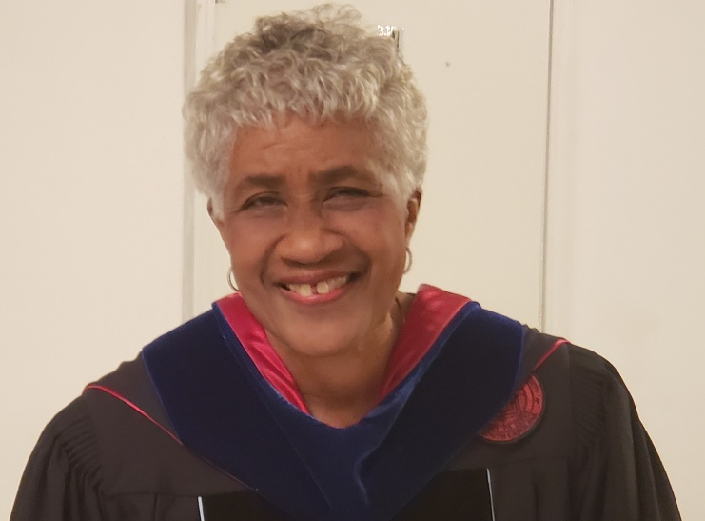

Dear Students,

The Student Handbook is designed to acquaint you with your rights and responsibilities as a student and the services, policies, and procedures that have been developed to enhance these rights and responsibilities. Additionally, this handbook serves as an aid in cultivating the kind of behavior conducive to a scholarly atmosphere that Central Christian University of SC, Inc., hereafter referred to as CCU of SC, Inc., believes is paramount.

I encourage you to read this important document. It is your responsibility to know the information presented in this handbook. If you have questions or concerns, please do not hesitate to contact me.

A special welcome is extended to our new students. Congratulations to our continuing students for deciding to continue your education at CCU of SC, Inc. The Division of Student Affairs is committed to assisting you in adjusting to the college experience. Additionally, we have dedicated student affairs professionals who will provide continuous learning opportunities for you outside the classroom.

It is always a pleasure to welcome back all continuing and new students. I am particularly interested in knowing how you view your experiences on campus and how we can enhance the quality of your tenure. This academic year, as you matriculate towards achieving your career goals in the service of our Lord Jesus Christ.

You are welcome to stop by my office if you need further clarification. Best wishes for a successful year.

Sincerely,
Mary O. Stover, Ph.D.
Dr. Mary O. Stover
Vice President of Institutional Advancement
Phone # (803) 786-6594
moastover@gmail.com ii
The History of Central Christian University of SC, Inc.

In Mims, Florida, on July 15, 1978, with much prayer and consultation, the C. E. Graham Baptist Bible Institute and Family and Pastoral Counseling Center were founded by Reverend Dr. Charles E. Graham, Pastor of the Greater St. James Baptist Church, Mims, Florida. It operated for six years as an extension of Faith, Evangelist, Christian Bible College in Morgantown, Kentucky, and the National Christian Counselors Association (NCCA) in Sarasota, Florida.

The compelling need for such an opportunity became a challenge for Dr. Graham when he, a young pastor at the age of 37 years, discovered that his congregation needed deacons. Upon asking a bright young man who appeared to possess a hunger for spiritual knowledge to consider training to become a deacon, Dr. Graham was confronted with the weakness that most Black people in that area silently and secretly carried. This young man could not read or write. He desired to study and train; therefore, he asked Dr. Graham to teach him to read and to write.

In concern for the dignity of the young man and at the admonition of the Holy Spirit, Dr. Graham consented to teach the rising deacon if he would carry Dr. Graham to lunch. The deal was sealed with a handshake.

As Dr. Graham began the work that had been preconditioned, other preachers and lay workers in other churches who had been recycling sermons from others and themselves because they also could not read and write, began to seek out this young “teacher-preacher” to teach them. These spiritual soldiers no longer wanted to preach “Hear Say Sermons.” They desperately wanted to read the Word and have the Word speak to them so that God’s wisdom would abound. They wanted to be independent biblical scholars who created their sermons as the Holy Spirit prompted them. They wanted to interact with each other and articulate the gifts given to them by the Holy Spirit. They became a cohesive, interdependent, yet individual group of learners. The fire had been ignited that could only be quenched by Knowledge, Wisdom, and Application.

After six years of operating as a Bible Institute and Family and Pastoral Counseling Center College, a need became obvious for the addition of a Bible college and Theological Seminary. On May 1, 1986, an amendment was made changing the scope of the Bible Institute and Counseling Center to the C. E. Graham Baptist Bible Institute/College/Seminary, still operating as an Extension of Faith Evangelistic Schools. In August 1988, Faith Evangelistic Schools was transferred to the leadership of Dr. Michael A. Smith due to the illness and death of Dr. James Bishop, the Founder of Faith Evangelistic Schools. After much prayer, another amendment was made to the Constitution to become an independent school and to be chartered in the State of South Carolina. In May 1993, the C. E. Graham Baptist Bible Institute/College/Seminary was chartered by the State of South Carolina as a non-profit corporation, operating at 4916 Fairfield Road, Columbia, SC. It became an independent school affiliated with Faith Baptist College and Seminary, Church Point, Louisiana, as a Satellite school with full accreditation from the American Federation of Christian Colleges and Schools and became a full member of the National Christian Counselors Association (NCCA), one of the largest associations of Christian Counselors in the world, headquartered in Sarasota, Florida.

The school also made a request to the South Carolina Commission on Higher Education to be exempt from the State Licensure requirements, offering studies leading to degrees in the areas of Bible Study, Theology, Counseling, Church Leadership, and Christian Education.
iii
On October 11, 1994, exempt status was granted clearance using degree titles such as Associate of …, Bachelor of …, Master of…, and Doctor of Theology, etc., which clearly label such degrees as professional.

On June 10, 2001, the school made another amendment to its bylaws to change its operational name to the C. E. Graham Bible Schools, Inc., because of the attraction of a wide variety of denominational backgrounds. On January 3, 2007, the School was chartered as Central Christian University of South Carolina, Inc.

To this date, Central Christian University of SC, Inc. is independent, liberal, and local church-oriented, meeting a neglected need in the field of Christian Education, Counseling, and Ministry. The University is missionary, both in belief and practice. Undergraduate, certificates, and diplomas are offered. Central Christian University of South Carolina, Inc. was accredited by Transworld Accreditation until 2013.
As the University has continued to prosper, Dr. Graham and the Board of Directors decided to increase the prestige and the appeal of the University by applying for accreditation with The Association for Biblical Higher Education (ABHE).

In February 2018, the ABHE Commission on Accreditation awarded Central Christian University of South Carolina, Inc. “Applicant Status.” The University endeavors to complete this journey toward full accreditation with the Association for Biblical Higher Education with committed diligence.

Currently, Central Christian University of South Carolina holds “Candidate Status” with the Association for Biblical Higher Education Commission on Accreditation (5850 T.G. Lee Blvd., Ste. 130, Orlando, FL 32822, 407-207-0808). Candidate Status is a pre-accreditation status granted to those institutions that meet the ABHE Conditions of Eligibility and that possess such qualities as may provide a basis for achieving accreditation statute within five years. In 2023, The Council for Higher Education Accreditation (CHEA) recognized CCU of SC as a member to receive national information.

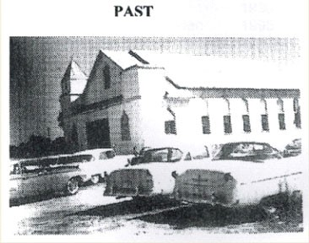
Historical picture of Greater St. James Missionary Baptist Church, Mims, Florida Founded 1904

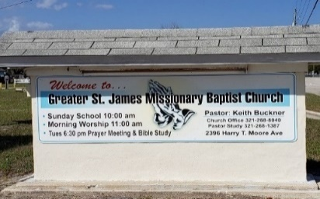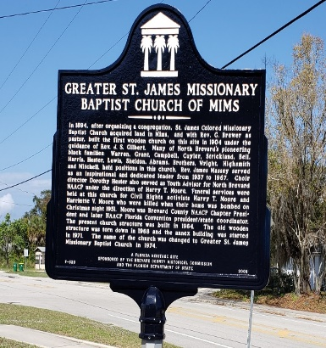

Current picture of Greater St. James Missionary Baptist Church, Mims, Florida
The New Geographical Location of Central Christian University of South Carolina

On August 22, 2023, Central Christian University of South Carolina applied for a Substantive Geographical Change to Belmont Baptist Church, 901 Mason Road, Columbia, SC 29203, with the Association of Biblical Higher Education.

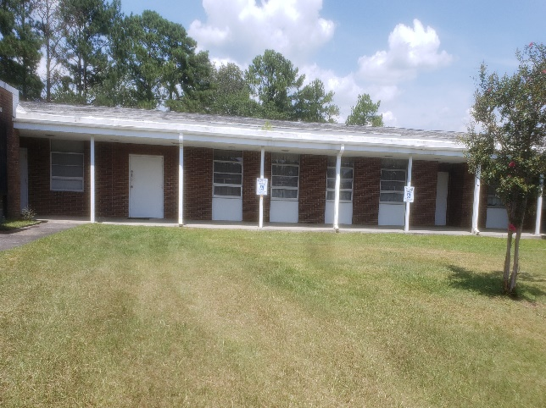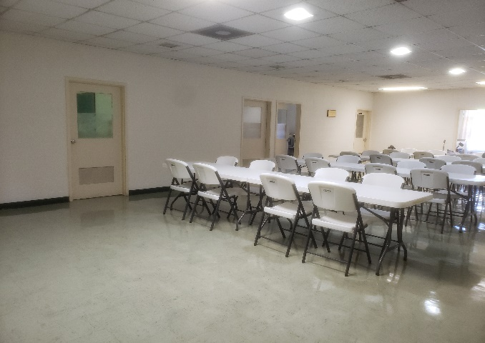

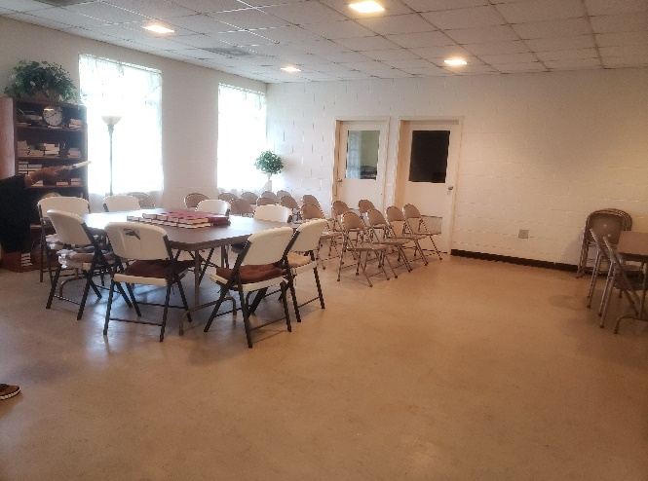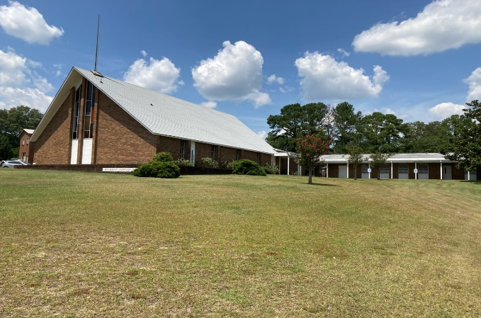

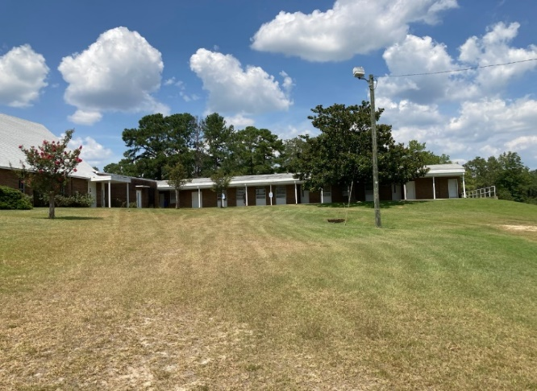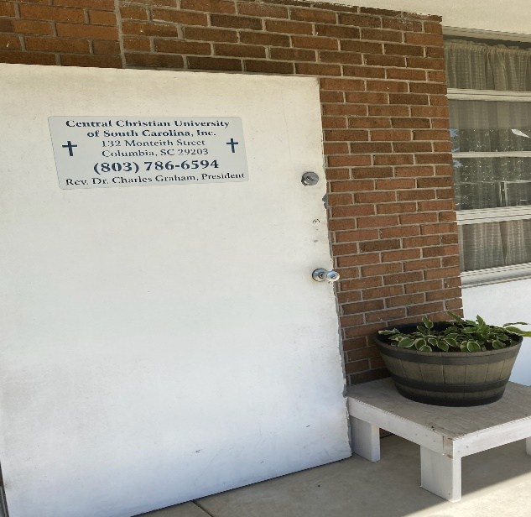

Central Christian University of SC, Inc. Board of Directors

Members:

Dr. James Andrews, Chairperson of the Board
Dr. Rev. Charles E. Graham, President / CCU of S.C., Inc.
Rev. Johnny Gibbs. Dr. Calvin Smith
Dr. Geneva Fleming, Dr. Carolyn Andrews, Secretary.
Dr. Lucious Dixon Dr. Ella Sims
Mr. Willie Jacobs Rev. Jason Graham, Alumni
Dr. Arthur Hart (Leave of Absence).
Dr. Malachi Simmons Mr. Willie Bryant
Dr. Simon Squire, Jr.
Dr. Tommie Richardson
Mrs. Tina Richardson
Dr. Novice Briggs
Dr. David Morrall
Dr. Herbert Brown
Mr. Charles Smalls
Dr. George Gaymon, Emeritus

Central Christian University of SC, Inc. Senior Executive Cabinet

Dr. Charles E. Graham President
Dr. Mary O. Stover Vice President of Institutional Advancement/ V.P of Academic Affairs
Mr. Rufus Stover Chief Financial and Information Officer
Dr. Daryl Hayes Director of Student Affairs
Dr. Carol Bowers Director of Library and Resources
Dr. Daryl M. Hayes Chairperson of the Faculty Committee
Dr. Gloria Watkins Department of Counseling
Mrs. Thelma Weston Executive Administration/ Registrar
Dr. Calvin Smith Director of Facilities/ Maintenance

Student Handbook Statement

This Student Handbook provides our students with information on various aspects of Student Life at CCU of SC, Inc., with regard to its policies and procedures, resources, activities and organizations, and University services.

The purpose of this Student Handbook is to provide students with a guide to understanding their rights, freedoms, and responsibilities as university students. It is imperative that students enrolled at CCU of SC, Inc. be responsible for abiding by the policies and regulations that are used to facilitate and sustain university policies and continue to uphold the University’s mission, vision, and core values.

1

The Campus

CCU of SC, Inc. was founded in Florida in 1978 and was incorporated in South Carolina in 1993. By scope and student population, the University is a small university that sits at 132 Monteith Street, Columbia, SC 29203. To enter the campus, a turn is required from Highway 321/ Fairfield Rd., Columbia, South Carolina 29203.
The University owns the property, and three buildings are used for the administration, library, classroom, and meeting room.

Central Christian University of S.C., Inc. possesses an official letter from the Greater Faith United Missionary Baptist Church to occupy the sanctuary, bathrooms, kitchen, fellowship hall, and the four classrooms as needed if no conflict of time exists between both entities. This relationship is permanent and is in effect without coercion.

Behind the Administration Building and adjacent to the rear of the Library is a white concrete block, one-room building that serves as a meeting room for organizations in the community for a nominal fee. Rental contracts may be secured from the Registrar of the Central Christian University of S.C., Inc. All buildings are handicapped accessible.

An extension of the campus is housed at Belmont Baptist Church, 901 Mason Road, Columbia, SC 29203.

Central Christian University of S.C., Inc. owns one vehicle (van) that seats 12 adults comfortably to be used for off-campus, educational excursions.

* Mrs. Thelma Wheeler, Executive Secretary/ Registrar
*Mr. Rufus Stover, Finance Officer

The Campus Committees

The Graduation Committee The CCU of SC Faculty
Dr. Mary Stover, Chairperson Dr. Daryl M. Hayes, Chairman
Dr. James Andrews Dr. Gloria Watkins
Dr. Daryl Hayes, Dean of Student Affairs Dr. Daryl Hayes
Dr. Charles Graham Rev. Mary Smith
Dr. Gloria Watkins Dr. Mary O. Stover
Dr. Walter Capers

Faculty Curriculum Committee
Dr. Daryl M. Hayes, Chairman Administration Staff
Dr. Gloria Watkins Dr. Daryl Hayes, Dean of Student Affairs
Dr. Mary O. Stover Dr. Shirley Brown, Student Advisor
Minister Ethel Richburg, Dr. Calvin Smith, Property Management Services
Dr. Daryl Hayes Dr. Charles E. Graham, President
Dr. Mary O. Stover, Vice President
Theology Mr. Rufus Stover, Finance Officer
Dr. Jamey Graham, Dean of Theology Mrs. Thelma Weston, Secretary/ Registrar
Dr. Charles Graham
Dr. Mary O. Stover Honorary Committee
Dr. Charles E. Graham Dr. David Morrell
Dr. James Andrews.
2
Mission Statement of Central Christian University of SC, Inc.

Central Christian University of S.C., Inc. is a multi-ethnic community dedicated to the preparation of men and women for manifold ministries to Christ and His Church.

Under the authority of the Holy Spirit and the Scriptures, we seek to fulfill our commitment to ministry education, preparation, and spiritual formation. CCU of SC, Inc., strives for excellence in all its ministries in the service of Jesus Christ under the guidance and power of the Holy Spirit and Holy Spirit-filled men and women who have been trained in the field of education and ministry.

Mission Statement-

“…is to equip and empower the body of Christ to do the work of the ministry and to advance the kingdom of God. To provide biblical education and training that promotes spiritual growth and maturity, and empower believers to live successful and victorious lives in Jesus Christ.”

Under the expert leadership of the Holy Spirit and men and women called and equipped in Christian education, Central Christian University of S.C., Inc., has continued to grow through the years and has become a leader in the implementation of higher education by the development of new programs to meet the needs of the church and the Christian community around the world.

From a rich heritage of ministry spanning one generation, God has established an educational organization of integrity and power for implementing God's purposes on earth. With a firm foundation in post-secondary Christian education, Central Christian University of S.C., Inc. has become a strategic hub for Christian leadership and Ministry.

Vision and Goal Statements of Central Christian University of SC, Inc.

As an educational arm of the church, Central Christian University of South Carolina, Inc., seeks to serve the body of Christ in its worldwide ministry, combining the following emphasis in the type of training we provide in Professional Competence, Multi-denominational Breadth, Vocational Diversity, Personal Maturity, and Social Concern.

Core Values of CCU of SC, Inc.
Our core values are selected principles that govern our behavior and operation as an organized body:

- Integrity: CCU of SC, Inc. seeks to practice truth and propriety in our personal and corporate practices and relationships.

- Accountability: CCU of SC, Inc. accepts its responsibility to be consistent in sound
practices, loyal in reference to duties, agreements, obligations, and relationships.

- Respect: CCU of SC, Inc. aspires for its faculty, staff, and students to live and work in harmony with peers, by respecting each individual’s right to exist, think and speak in an appropriate manner. The dignity of each one will be honored by all.

- Excellence: CCU of SC, Inc. is committed to the vigorous pursuit of excellence in our educational endeavors. 3
- Faith: CCU of SC, Inc. is a Christian institution of higher learning in religious studies under the auspices of the SC Baptist Convention and the National Baptist of America, Inc.

Goals of CCU of SC, Inc.

- To increase the students’ competence in professional knowledge and skills.
- To enhance the integration of Biblical principles into the students’ daily disciplines.
- To glorify God in the highest standards of Christian living while fulfilling God’s call upon their lives.

4
Criteria for Admission…

Generally, admission to Central Christian University of S.C., Inc. requires, first of all, that one must be born again; second, be willing to learn, have a high school diploma/G.E.D., an application form completed and signed, considered on an individual basis by the admissions committee. Special admission applicants without a fully completed high school diploma will be considered on an individual basis if they are over the age of 18. The following criteria must be met for acceptance to a regular degree-seeking status:

1. High intellectual achievement and scholarship as evidenced by grades, entrance exams, and academic recommendations. Specifically included:

- A cumulative GPA of 2.0 is based on a 4.00 scale. A minimum 3.00 grade point average in the major is desired.

- Must successfully complete with CCU of SC 12 hours before consideration as a continuing student is granted.

- Each applicant must have a personal interview with an educational consultant to review his or her application and transcripts and determine the appropriate degree program the student should follow. These interviews must be in person.
2. Students are required to work individually with an advisor on an ongoing basis throughout each semester. This advisor helps the students set academic goals, develop a course schedule, adapt to college life, and identify and solve potential problems before they become crises. The advisor also assists the student when additional direction is needed.

In keeping with our philosophy, the admissions department gives attention to –

- Scholarly attainment, as shown by a school record and examination (GED),
- The desire for continuing formal education,
(c) Character and personality traits,
(d) Emotional health,
(e) Leadership qualities.

Transfer Students
Students transferring from recognized Bible seminaries will be given advanced standing to the extent that their credits approximate the curriculum of CCU of SC. Since CCU of SC deems its courses essential for graduation, it will seldom be possible to extend credit for subjects bearing minor similarities or no similarities to those listed in the prescribed curriculum. Transferred credit hours that are accepted are not calculated as the CCU of SC cumulative GPA.
Courses graded less than “C” will not be transferred. Copies of previous transcripts are to be sent to the CCU of SC, Administrative Office of the Academic Dean for evaluation.
Upon completion of each evaluation, a CCU of SC official will notify the student regarding the number of credits accepted for transfer.

5
This information will be added to the student’s transcript at the time of the evaluation.
Transfer students must complete a minimum of 12 general education hours comparable to CCU of SC, Inc. from another reputable collegiate program to be eligible for the associate and the bachelor’s degrees, respectively.

CCU of SC encourages transfer students to apply for admission. University policy allows incoming students to receive credit for up to 50% (not to exceed 60 credit hours) of previous coursework towards a CCU of SC degree, pending review of an official transcript. (See admissions policy for guidelines).

- Completed undergraduate application.
- Official transcripts from all post-secondary institutions attended (he/ she must also submit a final, official transcript for all coursework in progress up until the time of enrollment) prior to beginning classes at the University.
- Official high school transcript (from a regionally accredited high school) if fewer than 30 semester hours of university-level work have been attempted in a regionally accredited university or university.
- Course description of all courses being submitted for transfer credit.
- To be considered for admission, the transfer applicant should have earned a minimum cumulative 2.00 GPA from a regionally accredited university or university.
- All applicants for transfer admission must be eligible to return to the last institution attended as a degree candidate. An official transcript from each institution attended must be sent directly to the Office of Admissions.

NON-DEGREE SEEKING STUDENTS
CCU of SC, Inc. welcomes an applicant who is not a candidate for a degree but wishes to take certain courses. These “special students” are required to complete the general admission procedures. A special student may become a degree candidate at a later date, provided all admission requirements have been met.

Previously Enrolled Students- Readmission:
When a previously enrolled student who has withdrawn from CCU of SC (either at the completion of a semester or mid-semester) desires to return, the following steps must be completed.

- Submit a completed re-enrollment application form.
- If the student has attended another college since leaving CCU of SC, an official transcript of all courses taken must be sent to the admission office. All transcripts must be official, sent directly from the college via email, mail, or delivered in a signed and sealed school envelope.
- All delinquent debt must be paid in full.

6

Information for Veterans and Eligible Dependents
The Office of the Registrar certifies educational benefits for veterans and eligible dependents. To ensure receipt of benefits, eligible VA students must inform the Registrar of their intention to register for classes and supply the number of credit hours for which they will enroll each semester.

After this information has been submitted to the Registrar, it is then submitted to the U.S. Department of Veterans Affairs for processing and payment.
First, students should apply for a certificate of eligibility at their nearest Veterans Affairs office at least six (6) weeks before the expected date of enrollment, or students may apply online at www.gibill.va.gov. All students receiving VA Educational Assistance payments from Veterans Affairs are responsible for immediately notifying the University’s VA Certifying Official of any changes in their degree program, excessive absences, and/or credit hour load during the semester. Veterans’ records are released upon request when accounts are up to date. At the request of the U.S. Department of Veterans Affairs, copies of a Veteran’s transcript will be forwarded to the Office of Veterans Affairs.

Admission Decisions:
In addition to the Criteria for Admission, the Admissions Department gives attention to –

Scholarly attainment as shown by the school record and examination,
The desire for continuing formal education,
Character and personality traits, Emotional health, and Leadership qualities.

Late Registration:
Specific dates are advertised/ presented for registering for classes. Should a student register outside the window of registration opportunity, but prior to the closure of registration, the student is responsible for making up any and all classwork that may have been missed due to the late registration.

Withdrawals & Change of Schedule…

After registration has been completed, courses are added or dropped through the Administrative Office of the Academic Dean, with the option of a service charge of $10.00 for each change or set of changes made at the same time. Course changes must be approved by the student's academic advisor before the change can be made. No course will be officially added or dropped until the change has been recorded on the student's permanent record.

By permission of the Registrar, students may add a course during the first week of classes or drop a course during the first two weeks of classes, without academic penalty. Courses dropped without permission after the first two weeks will receive an automatic "F". The Dean may permit a drop with either a "WF" or a "WP" in response to a written petition giving the reason for the request. Any course dropped after the seventh week receives an "F". (See Appendix A.)

Course Credit...

Central Christian University of S.C., Inc. uses the semester hour as the unit of credit awarded. One credit hour is 50 minutes of instruction per week for 17 weeks (or the equivalent). Most classes meet at least 150 minutes (2.5 hours) per week, plus 180 minutes (3 hours) outside for lab work, for 17 weeks, and carry three semester hours of credit. (7)
Classes meet in a one 150-minute session (2.5 hours) weekly and demonstrate home assignments/ labs equivalent to 180 minutes (3 hours) for 17 weeks to receive 3 credit hours.

Grading System
A 4.0 grading system is in effect:

A Superior 4 grade points
B Good 3 grade points
C Average 2 grade points
D Poor 1.3 grade points
F Failure 0 grade point
P Passing 0 grade point.
I Incomplete 0 grade point
V Audit 0 grade point
X Courses dropped without penalty 0 grade point
XF Courses dropped with a penalty 0 grade point.
7
WI Withdrawal Incomplete 0 grade point
WP Withdrawal Passing 0 grade point.
WF Withdrawal Failing 0 grade point.

A+ 4.0 C+ 2.5
A 3.8 C 2.3
A- 3.7 C- 2.0
B+ 3.5 D+ 1.5
B 3.3 D 1.3
B- 3.0 D- 1.0 F .0

Repetition of Courses

Failure in a course shall necessitate its repetition except by special permission of the professor of the course and the approval of the Registrar.

A student is permitted to repeat a course for which he has received a grade of "F," and the subsequent grade shall stand in the student's permanent record and be included in calculating the grade average. A student is not permitted to repeat a course for credit in which he has received a passing grade.

Requirements for Satisfactory Academic Progress…

The academic policy of the Central Christian University of S.C., Inc. is designed to ultimately meet the graduation requirement of a "C" average (2.00 GPA) on all work taken from the Central Christian University of S.C. through normal course enrollment. This includes credit by examination earned through taking a proctored exam.

To remain in good standing, a student must maintain a minimum cumulative grade point average according to the number of credits completed through Central Christian University of S.C. enrollment. The unit of credit is the semester hour. The following minimum grade point averages apply to students seeking a bachelor’s degree: (8)
Up to 30 credits....... l.50 GPA
31 to 44 credits........ 1.70 GPA
45 to 59 credits........ 1.85 GPA
60 credits or above. .2.00 GPA

Fostering Healthy Relationships at Central Christian University of SC, Inc.

As an evangelical and mission multi-denominational, international, and multi-ethnic community dedicated to the preparation of men and women for manifold ministries to Christ and His Church, our intent is to prepare individuals to be responsive to the call of God on their lives. We will achieve that mission by aggressively delivering high-quality educational materials and sound Biblical training to our students.

We will work hand in hand with the church leadership to promote the goals and vision of the local church.
“Our graduates will embody the highest aspirations of excellence in their academic pursuits, high quality in their professional work, and victory in their Christian life.”

Office of Financial Aid
The Office of Student Financial Aid (OFA) provides assistance to students and their families currently identified federal, state, and private resources that can help students pay for the costs of education are not available. Advice and assistance are provided in completing and submitting a necessary payment plan. The goal of OFA is to assist students in understanding their financial aid options while explaining how the system works. Students and their families are expected to contribute to the cost of college. If a family is unable to contribute the entire cost, a financial plan is available to eligible students to help bridge the gap. Knowing their financial aid options and how to obtain them is an important piece to funding students’ educational journey. Students may not know where to begin, and that is where OFA comes in to provide assistance, guidance, and information.

General Information

Bursar/Business Office (Campus Mall)

For questions or addressing issues involving student accounts, the Finance Officer can assist you with understanding monies applied and/or due to the student account.
Business Office Hours- Monday through Friday 9:00 A.M. to 5:00 P.M.

The CCU of SC, Inc. Library/ Media Center and Resources

Central Christian University of S.C., Inc. houses most of its resources in a building- the Charles E. Graham Library- situated on campus just behind the Administration Building on 132 Monteith Street. Resources are adequate to support the curriculum in response to the Conditions of Eligibility. As an institution offering graduate and post-graduate programs, the resources support original research and foundational study.
9
The library houses traditional classical bound materials, book volumes, bound written periodicals, and unbound periodicals in the form of CDs, DVDs, videos, and cassettes.

Additionally, the library houses three internet-ready, individual computers that are CD- and DVD-ready for students' use, along with four televisions equipped to show videos.

Seminars — Seminars offer an opportunity for in-depth study and discussion of various specific topics related to the school.

Practicum — A practicum gives a student an opportunity to gain practical experience in a particular field of study.

Independent Study — Independent study offers an opportunity for a student to do research, special projects, and reading, which will enrich his or her college program. Evangelism-Mission Trip (9 credits.)

Faculty and students are encouraged to utilize the Richland County Library on Assembly Street, Columbia, S.C.

Administrative staff and faculty are available to students by appointment and availability.

Library Operating Hours
Monday – 10:00 A.M. – 2:00 P.M. Thursday- 4:00 P.M. – 8:00 P.M.
Tuesday- 10:00 A.M. – 2:00 P.M. Friday – Closed.
Wednesday- 10:00 A.M – 2:00 P.M. Saturday – 9:00 A.M. – 5:00 P.M. (By Appointment Only)

Borrowing Privileges are available to enrolled CCU of SC students. All students must register at the CCU of SC Library/Media Center with their valid identification card to receive borrowing privileges.

Dress Code
Biblical precepts constitute the standard of conduct for all members of the CCU of SC, Inc. community. In matters of dress, students should recognize that they are preparing for ministry and career placement and, thus, should present themselves in a manner consistent with professional standards.

Student Non-Academic Grievance/Complaint and Appeal Process Policy Statement

CCU of SC recognizes the importance of providing a prompt and efficient procedure for resolving nonacademic grievances or appeals fairly and equitably. A non-academic grievance or appeal alleges discrimination by a university employee on the basis of race, color, sex, religion, national origin, age, or disability and may also involve personal behavior or university policy.

10

Procedures
The procedures below will be followed to resolve a nonacademic grievance or appeal:

- The student shall file a written grievance or complaint to the Office of the Dean of Student Affairs about the action that forms the basis of the grievance. The complaint shall contain a clear and concise statement of the grievance, the remedies sought, and a request for a meeting with the involved person or persons. The complaint must be filed within ten (10) days of the event unless there are extenuating circumstances.

- The respondent shall schedule a meeting with the student within 10 class days of the filed grievance, complaint, or appeal to discuss the matter. A written reply by the respondent to the student indicating the results of the meeting and including further action to be taken, if any, shall be attached to the written grievance.

- If the student is not satisfied with the results of the reply and wants the grievance to be considered further, the student shall appeal in writing to the Vice President for Student Affairs to seek a resolution. This consultation must begin within ten (10) class days after the conclusion of the reply to respondent.

A written reply by the Dean of Student Affairs to the students, indicating the results of the meeting and including further action to be taken, if any, shall be attached to the written appeal.

- The decision of the Dean of Student Affairs shall become the final campus decision on the grievance or appeal. A written reply by the Dean of Student Affairs to the student indicating the results of the meeting and including further action to be taken, if any, shall be attached to the written grievance or appeal. The student and appropriate university officials shall be notified in writing of the decision within ten class days after the last consideration of the grievance or appeal.

- Written documentation of the student’s complaint or grievance shall remain in the Office of Student Affairs for one academic year. At the end of the academic year, the documentation shall be destroyed.

DIVISION OF STUDENT AFFAIRS

The Division of Student Affairs is led by the Dean of Student Affairs. Student Affairs supports the university’s mission and core values by way of fostering the intellectual, personal, social, and professional development of all students. Student Affairs complements the academic development of each student through activities, programming, and support services to ensure students have a complete, transformative experience during their days at CCU of SC and prepares students for their leadership roles in a diverse, dynamic, and global society. Areas that comprise the Division of Student Affairs include: Enrollment Management (Registrar, Admissions, and Financial Aid), Counseling and Placement Services, and Student Conduct. (11)

Student Services and Development Program
The Student Affairs Motto: “Support, Develop, Succeed.”
The purpose of the Student Affairs Area is to serve and develop students through promoting services, resources, and solutions to facilitate students’ growth and success in their ministry.

The Student Affairs Office seeks to complete the following:
- Assemble and allocate resources: Determine, assemble, and allocate resources for effective student life administration.
- Embrace inclusion and diversity: Embrace leaders and students who advance the work of the university in preparing persons for effective ministry to a diverse world.
- Development: Students SPIES: Structure activities that develop students spiritually,
physically, intellectually, emotionally, and socially.

- Student retention-graduation: Apply effective measures to maintain at least a seventy percent retention rate to graduation.

- Work with other libraries: Identify and utilize services that benefit university education.
- Support students as the institution fondly “SPIES”, as we use the acronym.

Spiritual Development
Career Coaching. Christian career coaching services are offered in conjunction with ministry formation. To this end, the team helps develop and guide the students to be greater servants of our Lord and Savior Jesus Christ. In addition to being embedded in the structured academic offerings of ministry formation, students who are flagged as struggling in this area or who request further assistance may utilize this service.

Physical Development
Physical Disabilities: Students with disabilities or special needs may verbalize consideration for reasonable accommodations by calling or emailing our office or at student advisement services. Students may receive test-taking assistance, campus escort service provided by the Office of Student Affairs, or training on document read-aloud services provided by library services.

Intellectual Development
Tutoring. Academic support is provided through the offering of tutorial services. Students who struggle in class or desire increased knowledge may take advantage of these services.
Library Services-Information Literacy. Tutoring is offered in conjunction with faculty members and library services. Students may visit the Office of Student Affairs during office hours, request directly via faculty members, and submit an electronic Ask a Librarian or virtual reference request form located on the library’s web page to request tutoring assistance.

12
Emotional Development
Christian Counseling. In collaboration with the Office of Christian Counseling, to enhance the leadership mindset of our students, we offer moral, ethical, and spiritual Christian counseling. We offer Christian counseling based on the premise of the student’s first. Not only will students who are mentally, spiritually, and emotionally well perform better, but they will also provide better services. Students may request these services through our office or directly with the Office of Christian Counseling.

Social Development
Student Council. The incorporation of the voice of students in all facets of the university. Students may join the Council to promote ideas, contribute to governance, and provide student-led functions. Students are invited to express opinions about their educational experiences by completing assessments and surveys administered by the Assessment Committee.
Grievance and Complaint. Students may voice concerns and complaints by submitting a complaint form. Students may also submit community spotlights, articles to the campus newsletter, or items to the events calendar.

Office of Student Affairs and on-Campus Collaborations
Calibrating Department or Office | Mission or Purpose Statement of Collaborator
Ministry Formation | Our Christ-centered mission is in the spiritual, religious, and moral development of our students while providing training and practical experiences to develop effective Christian ministers and leaders.
Christian Counseling | Our mission is to prepare students with a Christian leadership mindset to provide moral, ethical, and spiritually sound counseling to individuals on multiple platforms.
Student Advising | We strive to provide academic advisement services and support to students throughout their matriculation at Central Christian University of South Carolina.
Library Resources | Library Resources provide innovative instruction, services, and resources to facilitate teaching, research, and learning.
Assessment Committee | The mission of the Assessment Committee is to conduct ongoing regular assessments to ensure institutional effectiveness.

13

ENROLLMENT MANAGEMENT

Office of the Registrar

Class Attendance
Absenteeism in class: A student is allowed to miss a class during a semester one time per credit hour for the given course (e.g., 3 times for a 3-hour course). These absences are without penalty as long as the reasons for the absence are acceptable to the instructor. The student must attend class a minimum of 70% of the time in order to be given credit for the course (except by consent from the faculty in extenuating circumstances).

It is assumed that students will make the most of the educational opportunities available to them by regularly and punctually attending class periods. Therefore, regular class attendance is required as a condition of receiving credit for work done in the class.
A student absent from a class period is subject to a loss of "privilege status," and the instructor may reduce the student's grade or deny credit for that course unless the student satisfactorily accounts for the absence. Distance Education students must make a monthly call-in or email to the Student Services Department.

Student's Right to Privacy Act
Federal laws protect the rights of all students. CCU of SC observes these laws that provide that the institution will maintain the confidentiality of each student’s official education record, as related to access to or the release of information. Reference: Family Educational Rights and Privacy Act (FERPA) of 1974, Sec. 438, Publ. L90-247, Title IV as amended, 88 Stat. 571-574.
The official policy and specific provisions of CCU of SC are as follows:
- CCU of SC recognizes the privacy rights of all students from the time of their official registration at the University. The University permits each student who is or has been in attendance at the University to inspect and review his/her educational records.

- Educational records include only those records maintained by the Registrar’s Office that are directly related to students. All educational records are kept in the Registrar’s Office
and maybe inspected on normal working days by appointment when the University is
in regular sessions, except during registration periods.

- Students who wish to inspect and review their educational records must request an appointment in writing to the Registrar’s Office. For students who are currently enrolled, appointments will be scheduled no later than five working days after receipt of the request for an appointment. For students who are no longer enrolled, appointments will be scheduled no longer than fifteen days after receipt of the request.
14
- A minimum fee per page will be charged for unofficial copies of educational records and copies of information disclosed from educational records. The Registrar’s Office will deny a request for copies under the following conditions:

  - Improper or insufficient identification; or
  - Non-payment of fees.

- The University recognizes the right of a student to seek correction of information the student believes to be inaccurate, misleading, or in violation of his/her privacy rights. If a request for correction is denied, the student will have the right to a full and fair hearing. If the student is dissatisfied with the findings of the hearing, he/she will have the right to place a statement in his/her educational records concerning his/her disagreement with the findings of the hearing and/or comment on the disputed information.

- The University requires that a student give prior written consent for the disclosure of any personally identifiable information from his/her educational records, except when the disclosure is to administrative officials of the University and their staff, empowered
by the president of the University to review such records in the execution of their duties, and when prior consent for disclosure is not required by law.

- The University shall disclose directory information from the educational records to any member of the public who submits a legitimate request in writing with the proper picture identification and official purpose. Directory information includes:
  - Name of student.
  - Name(s) of parent(s) or other family member(s) of each student.
  - Student addresses.
  - Personal identifiers, such as social security numbers.
  - All other information, which would make the identity of the student easily traceable.

- Any student who does not wish to have his/her directory information disclosed should notify the Registrar’s Office during registration at the beginning of each semester in writing.

- The University prohibits all third parties receiving information from student educational records from disclosing such information to any other party without the prior written consent of the student(s) involved.

- The Registrar’s Office will maintain a record of requests/disclosures for each individual student's folder.

- The University recognizes the right of a student to waive any or all of his/her rights under Act 438 and the right of a student to revoke a waiver at any time, provided that the privacy rights of a student apply only to entries made in his/her educational records after revocation. 15
- Parents of students under the age of 18 do not have to request permission or obtain waivers from the students to examine the educational records.

- The Dean of Student Affairs is responsible for the effective administration of this policy, seeing to it that access to educational records is afforded to students without undue delay and that all requests are handled promptly within the guidelines of this policy. The Dean of Student Affairs will maintain such records to show compliance with Act 438.

Office of Admissions

Admission Policy
Generally, admission to Central Christian University of S.C., Inc. requires, first of all, that one must be born again; second, be willing to learn, have a high school diploma/G.E.D., and an application form completed and signed, considered on an individual basis by the admissions committee. Special admission applicants without a fully completed high school diploma will be considered on an individual basis if they are over the age of 18. The following criteria must be met for acceptance to a regular degree-seeking status:

1. High intellectual achievement and scholarship as evidenced by grades, entrance exams, and academic recommendations. Specifically included:

- A cumulative GPA of 2.00 based on a 4.00 scale. A minimum 3.00 grade point average in the major is desired.

- Each applicant must have a personal interview with an educational consultant to review his or her application and transcripts and determine the appropriate degree program the student should follow. These interviews must be in person.

2. Students are required to work individually with an advisor on an ongoing basis throughout each semester. This advisor helps the students set academic goals, develop a course schedule, adapt to college life, and identify and solve potential problems before they become crises. The advisor also assists the student when additional direction is needed.

In keeping with our philosophy, the admissions department gives attention to –

(a)Scholarly attainment as shown by a school record and examination (GED),
(b)Desire for continuing formal education,
(c) Character and personality traits,
(d) Emotional health,
(e) Leadership qualities.

CCU of SC currently provides educational opportunities to applicants of all racial groups who meet the admission criteria listed below.

16
The Admissions Retention Policy
CCU of SC will maintain records that fall under only applicants’ records. Applicants’ records include information about the applicant's name, gender, birth date, home address, telephone number where parents or legal representatives may be reached, and emergency numbers. Other types of applicant records include admission forms, release of information forms, and VISA and passport information.

When to apply and enroll. Central Christian University of S.C., Inc. operates on a continuous enrollment system. This means that any qualified applicant may enroll in courses and/or degree programs offered by Central Christian of S.C., Inc. at any time.

The applicant must meet the established admission requirements, including approval by the Admissions Committee.

Students whose academic careers have been interrupted because of long-term illness (days beyond the minimum number of excused absences, academic probation, failure to remain in satisfactory financial status, or suspension) may appeal or reapply for admission the next subsequent semester. Because our community is commute-based and is adults 18 years and older, there are no considerations of expulsions. The exceptions are illegal/ criminal ramifications.

Non-Discrimination Policy
CCU of SC, Inc. admits students of any race, religion, color, national and ethnic origin to all the rights, privileges, programs, and activities generally accorded or made available to students at the school. It does not discriminate based on race, religion, color, national or ethnic origin, or sex in the administration of its educational policies, admission policies, employment policies, and scholarship and loan programs. CCU of SC, Inc. does not discriminate in admissions or access to or employment of persons with impaired vision, hearing, or physical mobility.

ADMISSION CONTACT
Office of Admissions
CCU of SC, Inc.
901 Mason Road
Columbia, SC 29203

APPLICATION
Applicants may complete and submit their application online via the CCU of SC, Inc. Website at www.ccuofsc.org. Once properly submitted, the University will send the applicant an email notification of receipt.

OR
Paper Application
To receive a hard copy of the paper application, applicants may contact the Office of Admissions to have an application packet sent via the mail, or he/she may download and print a copy via the CCU of SC Website by going to www.ccuofsc.org.
17

Note: It is important that all information is entered legibly, and all appropriate sections are completed in their entirety. Applications that are unsigned cannot be processed.

TRANSFER STUDENTS
Students transferring from recognized Bible seminaries will be given advanced standing to the extent that their credits approximate the curriculum of CCU of SC. Since CCU of SC deems its courses essential for graduation, it will seldom be possible to extend credit for subjects bearing minor similarities to those listed in the prescribed curriculum.
No courses used as credit toward undergraduate degrees will be accepted as credit toward a graduate degree. Courses graded less than “C” will not transfer. Copies of previous transcripts are to be sent to the CCU of SC, Administrative Office of the Academic Dean, for evaluation.
Upon completion of each evaluation, a CCU of SC official will notify the student regarding the number of credits accepted for transfer. This information will be added to the student’s transcript at the time of the evaluation.
Students must complete a minimum of 12 general education hours comparable to CCU of SC, Inc., from another reputable collegiate program to be eligible for the associate and bachelor’s degrees, respectively.
CCU of SC encourages transfer students to apply for admission. University policy allows incoming students to receive credit for up to 50% (not to exceed 60 credit hours) of previous coursework towards a CCU of SC degree, pending review of an official transcript. (See admissions policy for guidelines).

- Completed undergraduate application.
- Official transcripts from all post-secondary institutions attended (you must also submit a final, official transcript for all coursework in progress up until the time of enrollment, prior to beginning classes at the University)
- Official high school transcript (from a regionally accredited high school) if fewer than 30 semester hours of university-level work have been attempted in a regionally accredited university or university.
- Course description of all courses being submitted for transfer credit.
- To be considered for admission, the transfer applicant should have earned a minimum cumulative 2.00 GPA from a regionally accredited university or university.
- All applicants for transfer admission must be eligible to return to the last institution attended as a degree candidate. An official transcript from each institution attended must be sent directly to the Office of Admissions.

NON-DEGREE SEEKING STUDENTS
CCU of SC, Inc. welcomes an applicant who is not a candidate for a degree but wishes to take certain courses. These “special students” are required to complete the general admission procedures. A special student may become a degree candidate at a later date, provided all admission requirements have been met.

18
PREVIOUSLY ENROLLED STUDENTS-RE-ADMISSION:
When a previously enrolled student who has withdrawn from CCU of SC (either at the completion of a semester or mid-semester) desires to return, the following steps must be completed.

- Submit a completed re-enrollment application form.
2. If the student has attended another college since leaving CCU of SC, an official transcript of all courses taken must be sent to the admission office.
All transcripts must be official, sent directly from the college via email, mail, or delivered in a signed and sealed school envelope.

3. All delinquent debt must be paid in full.

LATE REGISTRATION:
Specific dates are advertised/ presented for registering for classes. Should a student register outside the window of registration opportunity, but prior to the closure of registration, the student is responsible for making up all classwork that may have been missed due to the late registration.

APPLICATION PROCEDURES

- Request that official high school and university(s) transcript (s) of academic records be mailed to the Office of Admissions. All transcripts must be received in the Office of Admissions before admissions consideration will be given.

NON-DEGREE STUDENTS
- Request an application from the Office of Admissions, CCU of SC, 901 Mason Rd. Columbia, SC 29203. Telephone number: (803) 786-6594
- Return the completed application forms to the Office of Admissions.
- Request that official high school and university transcripts of academic records be mailed to the Office of Admissions.
- Request that General Education Development Examination (GED) scores be sent directly from the state testing center to the Office of Admissions.

PROVISIONS FOR DISABLED AND SPECIAL NEEDS STUDENTS

The University makes provisions to accommodate disabled and special needs students, except those who are completely blind.
ALTERNATIVE ACADEMIC PATTERNS

The alternative academic courses at CCU of SC are very descriptive and consistent with those taught on campus. The title of the courses in the catalog is similar to the course online training courses. The syllabus contains the same content, the school mission statement, and the required textbook. Other features that are similar to the syllabus are:

19
- Clear and measurable learning outcomes are characteristic of similar patterns in the undergraduate program and regular academic patterns in the institution.
- Assessments that can show to what extent the students have met the learning outcomes.
- Activities and other active learning strategies to allow students to practice doing what is described in the learning outcomes.
- CCU of SC tolerates no forms of falsification. The use of artificial intelligence is to be used with prudence and wisdom.
- Content provides sufficient information, explanation, and demonstration, in both written and visual forms, so that students can successfully accomplish the learning outcomes.
Library resources also include books, DVDs, CDs, cassettes, books, and a host of electronic resources. Students are responsible for accessing the technological resources necessary for the completion of academic responsibilities and assignments.
CCU of SC has adequate staffing, facilities, and technology to support programs in all delivery modes.
Since students have access from anywhere at any time, the instructor must ensure that the person performing the work is the person identified. Daily screenshots are taken during our class sessions to verify attendance. Some safeguards, such as students must log in to join the meeting on zoom.com, and only students are given the correct meeting ID and password from a secure source, in order to participate in the session to complete their coursework. (The admit button will let the instructor know when a student wants to enter the session.)

Instructors will save individual important assignments of their students in a file on their computer or make hard copies to be filed. If students commit fraud by providing answers from previous assignment assessments, cheating is constituted, and the student (whether spouse or classmates) will receive a zero for the assignment. Procedures for taking exams and submitting test questions are detailed in the procedures listed below.

Students who are enrolled in online learning must receive a briefing and participate in a conference at the beginning of the term on the utilization of the “Zoom program” correctly during their semester coursework at CCU. They are given specific guidelines for participating in classroom assignments and provided the class ID and correct password in a timely manner before the class begins. They are required to bring their picture ID with them and present it when turning in their homework assignments. The instructor will take a screenshot to confirm that the person completing the assignment is the same individual.

The following guidelines are implemented:
- Teachers will inform students in advance of the date and time for class meetings and timely reporting. Teachers must technically admit the students when their names appear on the entrance key on Microsoft Teams.
- Students are notified by email at least three (3) days what handouts, supplies, and references, along with the designated textbook and syllabus, are required for each class.
20
- The mission of the college is stated frequently during each class meeting so everyone will acknowledge it.
- Previous lessons are reviewed, and the instructor may give general comments on graded assignments and how they can be improved if necessary.
- Students must bring their laptops with their webcam on, so the teacher may observe students during the class sessions and have a workable printer available to send clear copies of assignments when submission is required.

- Students are given a valid i-Cloud recording after class if they must leave early or are absent from a class session.
- Rubrics are given for grading assessments: journals, final written assignment projects, and sermons or discussions for the student’s benefit in preparing final projects.
- Clear directions are given for MLA requirements in presenting the correct format on all written assignments. If students plagiarize any assignments, they will receive a failing grade or be allowed time to complete and resend the new assignment for grading. These projects are covered in the Faculty Handbook under Faculty and Student Relationships.

PROTECTION AGAINST FRAUD IN E-LEARNING SYSTEMS
With so much personal privacy information and possible security risks against some of the intelligence gathering by organizations, especially in the educational arena, recently, safeguards afforded by SIS and CMS (Content Management System) are necessary. Internal and external investigations and knowledge of fraud detection and preventive measures will limit the risk of educational institutions such as CCU of SC.

GRADUATION REQUIREMENTS
Upon satisfactory completion of degree requirements, Central Christian University of S.C., Inc. will confer a degree on the student. An application for an undergraduate degree must be filed with the Registrar during the spring semester prior to graduation. Forms for the announcement of candidacy are available in the Academic Department and must be completed by the student and signed by his/her faculty advisor and/or mentor.

Graduation exercises are held at the end of the spring semester. Normally, they are held on the fourth Saturday in June. Independent study students are required to attend their personal graduation exercise. Exemption from attendance may be received by special request. Diplomas are released on the appropriate dates.

The following requirements must be met for graduation:

Satisfactory completion of all requirements, including required courses, thesis, and comprehensive examinations.
- A minimum cumulative grade point average of 2.00.
- Graduation Approval Form completion with faculty signature.
- The student's account is paid in full.

21

FINANCIAL INFORMATION…

TUITION: CCU of SC NCCA: Christian Counseling

$100.00 Registration Fee $100.00 Registration Fee
$750.00 Per Course undergraduate level $292.00 Per Course
$50.00 Per Credit hour audit (discretionary)
Courses are awarded completion by credit hours. Courses are awarded a minimum of three credit hours per course.

A “CREDIT HOUR” is the unit of measuring educational CREDIT, usually based on the number of classroom hours per week throughout a term. Students are awarded credit for classes on the basis of the Carnegie unit. This defines a semester unit of credit as equal to a minimum of three hours of work per week for a semester.

GRADUATION FEES
CCU of SC NCCA: Christen Counseling

$100.00 Associate* $150.00 Membership Fee
$125.00 Bachelor* $1,500.00 Matriculations/ Processing Fee
*Fees include cap, gown, and tassel. (other fees may apply)
*This fee is required for all students who graduate, whether
they participate in the commencement ceremonies or not.

STUDENT ACCOUNTS

Tuition and Fees. Central Christian University of S.C., Inc. relies on the income derived from tuition and fees to ensure that high-quality programs are offered. Tuition cost is assessed on a semester credit hour basis. Tuition may be paid in full when activating the Registration. The Registration is the document that details the student’s courses and degree program requirements. Students may choose to use the deferred monthly payment option for tuition (see Payment Plans below) when payment in full for tuition is not a viable alternative. See the tuition section in this catalog for current tuition costs. All fees (other than tuition) shown on the Registration are to be paid in full upon activation of the Registration, regardless of the payment method chosen. Books are not included in the tuition cost.

Financial Aid. Internally subsidized financial aid is available to qualifying applicants based upon the Board of Regents-approved criteria.
Initial consideration for Central Christian University of S.C., Inc., financial aid is given during the admissions process. When students are ready to register for additional courses, they may request subsequent consideration for financial aid by contacting Enrollment Services. External financial aid is available through the Veterans' GI Bill.

Payment Plan. Central Christian University of S.C., Inc. relies on the income derived from tuition and fees to ensure that high-quality programs are offered.
22
The University desires to help students in preparing a financial plan that will not cause financial hardship. This can be accomplished by considering applicants’ income resources, needs, and the availability of internally subsidized financial aid. Tuition cost is assessed on a semester credit hour basis. Tuition may be paid in full when activating the Degree Plan. The Degree Plan is a document that details the student’s courses and degree program requirements. Students may choose to use the deferred monthly payment option for tuition when payment in full for tuition is not a viable alternative. See the current tuition costs section in this catalog.

All fees (other than tuition) shown on the Degree Plan are to be paid in full upon activation of the Degree Plan, regardless of the payment method chosen. Books are not included in the tuition cost. A late fee will be assessed if payment is not received on or before the payment due date. The University reserves the right to suspend or dismiss a student for non-payment of amounts due. In the case of a suspension, a fee of $75 will be charged for reinstatement after the account is paid in full. Prior balances must be paid in full in order to be eligible to complete the registration process each semester. Central Christian University of S.C., Inc. will not issue transcripts or diplomas until the student's account is paid in full. Optional automatic monthly payment plans, including credit card and direct debit, are available through the Finance Department.

Refund Policy. All withdrawal and/or refund requests must be in writing from the
student. The withdrawal/refund period is computed using the Registration activation date
and the date the withdrawal/refund request is received in the Central Christian of S.C. office. The refund policy is as follows:

•Up to four weeks after the Registration activation date, 20% of the original tuition
cost is payable.

•From the fifth through the eighth week after the Registration activation date, 50% of
the original tuition cost is payable.

•After eight weeks following the Registration activation date, 100% of the original
tuition cost minus any financial aid is due and payable to Central Christian University of S.C., Inc.

“Original tuition cost” is the amount of tuition before any financial aid has been applied.
If a student withdraws during the refund period, all financial aid funded by Central Christian University of S.C., Inc. is forfeited. This includes any grant or scholarship provided through Central Christian University of S.C., Inc. As is consistent with other educational institutions, tuition charges at Central Christian of S.C., Inc. are not based on student progression in a degree program. Therefore, students who do little or no coursework are not relieved of their financial obligation.

Retention of applicants’ records. All records on active applicants should be maintained for the duration of the current admission. If the applicant enrolls and validation of enrollment is final, the records must be sent to the Registrar's Office a month after validation. Records of applicants who did not enter the University will only be retained for one year.

23
Retention of program policies and procedures. Program policies and procedures should be maintained until they are no longer required or until the policy and procedure are replaced by a new policy or procedure. The University must also comply with record retention requirements established by our state and federal agencies that have jurisdiction over specific aspects of our program (if any), South Carolina Commission on Higher Education:
October 30, 2017.
Procedure for Reporting Incidents, Crimes, and Emergencies.
If you are the victim of an incident or crime, do not assume someone else will or has reported it. You, the student, should report any incident, crime, suspicious behavior, or emergency immediately. The following procedures should be taken when reporting:

- If any of the above occurs on campus, contact the Administrative Office- (803) 786-6594
- If any of the above occurs away from the campus, call 911 immediately.

Fire Drills and Safety Procedures
In accordance with state law and for the safety of the students, fire drills will be conducted at each building at various times throughout the semester. All persons must vacate the buildings during the drills and remain outside until instructed to return. Evacuation procedures will be posted in each building. Smoke detectors are located in each building, and fire extinguishers are provided.

ACADEMICS:
FACULTY AND STUDENT-RELATED POLICIES

PRESENTATION AND PUBLISHING A SYLLABUS
At the beginning of the semester, teachers will provide all students with a syllabus, or course plan, containing the following:
- The mission statement of the university, as required by ABHE mandates.
- A list of all written text materials to be used in the course and an indication of when they are to be used. Please do not require students to purchase expensive books unless they are used extensively in your class.
- A calendar of all class sessions, with specific dates indicating what topics are to be covered in each class and when examinations will be held.
- A clear statement of written work assignments or other projects, including their due dates, required length, and grading standards.
- A statement of teacher policy on late attendance, absences, and incomplete or late written work.
- An indication of how grades will be determined, specifying expectations for those choosing the Credit/No Credit option as well as for letter grades.
- A statement concerning academic integrity and possible sanctions for plagiarism (see the Academic Integrity section of this handbook for a sample statement).
24
- As teachers prepare their syllabus, please review the course description published in the University Course Schedule. Students enroll in courses on the basis of the descriptions, and it is important that instructors attempt to adhere to them in the teaching of their courses.
- All syllabi issued at CCU of SC must conform to all mandates of ABHE as delineated in its standards section of the compliance documents.
- A SIGNED CONTRACT
All students will be given a course contract upon approval from the Vice-President of Academic Affairs, Dr. Mary Stover. This record will remain on file in the CCU of SC central office. (See Appendix # 3.)

STUDENTS:

- CONFIDENTIALITY
Federal law specifies that student attendance and personal information such as addresses, telephone numbers, and grades are not to be disclosed to any third party-including spouses and parents-except to school officials with legitimate educational interest. If a student is hospitalized or otherwise unable to attend class, the information is to be treated as confidential. The request should be made to the Dean of Students or the Registrar.

- ACADEMIC DISHONESTY
If students are suspected of cheating, their instructor will inform them. The student may explain or refute the allegation.
If the instructor still thinks the charges are founded, the student will be referred to the CCU of SC Dean of Student Affairs, who will listen objectively to the explanations offered and may rule on the findings or refer the student to the Vice-President of Academic Affairs. He/ She will receive a letter with the sanction grade of zero (0) and any other sanctions deemed appropriate. Students have the right to file an appeal. Once the hearing and the notice of the right to appeal have been completed, the instructor will be notified to apply the sanction grade of zero (0) or meet the optional solution.

- EMERGENCY
For medical emergencies, students should get help immediately. Go to the nearest phone or have someone call from their cell phone 911 or the local police if it is a criminal matter. For non-life-threatening emergencies, have someone notify the faculty member in charge if the incident occurs during a class session or immediately afterward.

- MEDICAL EXCUSES AND ABSENTEEISM
Students are expected to attend every class section of all courses for which they are registered. They are not permitted to have a certain number of absences. If there are medical reasons, students should provide legitimate excuse documents, but they should notify their instructors as soon as possible, either by text, email, or another medium, for missed coursework that will affect their academic performance. Students enrolled in online classes should notify the instructor or the Director of Christian Education as soon as possible, even if it is due to military service, such as National Guard or Reserve Duty.

25
ATTENDANCE POLICY
The Central Christian University of SC has mandates that we must observe to remain in good standing with the Accrediting institution and consistently maintain our professionalism in the educational arena to be competitive with similar programs in biblical studies. We must, therefore, hold our students to the same level of professional character and mannerism as other accredited schools. Students must attend all classes needed to be successful in this type of college credit class and are assessed only three (3) unexcused absences, or they will not receive credit for the course. If it is necessary to be away for official duties, illness, death, or other unforeseen legitimate incidents, the students must notify their instructor immediately. There will be no deviation from this policy unless there is extreme hardship or unusual circumstances, like the most recent flash floods or weather phenomenon, so classes have to be canceled.

CHANGE IN TIME AND PLACE OF MEETING CLASS
In general, a change by a faculty member in the time and/or place for holding a class is discouraged. If it becomes necessary in special circumstances, arrangements for changing location and/or time may be made through the appropriate Dean of Academic Affairs and ensuring that all students enrolled are accommodated and notified in a timely manner. Prior to the completion of such arrangements, faculty members are expected to hold their classes at the times and places originally specified. All changes should have the approval of the Dean of Academic and the President, when necessary, for the use of the facility.

DISRUPTIVE BEHAVIORS- In the Faculty Handbook, but states differently?
Behavior that disrupts the learning environment is not tolerated. The students will, at all times, conduct themselves with professionalism, courtesy, and respect for all constituents of the University.

STUDENT COMPLAINTS

The faculty should advise students who have a complaint to attempt to resolve issues and concerns directly with the employee with whom they have a concern. If students are unable to resolve the issue with the employee, they should be referred to the Dean of Students, or in their absence, contact the Academic Dean or Vice President of the University.

FINAL EXAM COURSE GRADE

Faculty members are expected to evaluate the work of students enrolled in college-level credit courses and to assign grades. Evaluations may include test or study questions, homework assignments, quizzes, in-class essays, writing assignments, journals, projects, oral presentations, or other assignments. These should be designated at the beginning of the course and described in detail in the course syllabus. At the end of the semester, faculty will submit final grades to the Registrar based on the school calendar or schedule. Students who complete a course will receive a passing grade of A, B, C, OR D, and a failing grade of F. For students who do not complete the course, a grade of I, W, or F is appropriate based on school policies and mandates by the Registrar and Academic Dean.

26

SPECIAL NEEDS AND DISABILITIES

Disabilities Statement: CCU of SC wants to ensure that all educational programming and services are accessible to otherwise qualified students with disabilities. If students have a concern regarding the accessibility of websites, instructional materials, online courses, and other electronic or information technology, please contact the Dean of Students or the Director of Christian Education. It is the student's responsibility to self-disclose as a student with a disability and to request accommodation prior to beginning a program or course. Students are to contact the Registrar when they apply, and they will require special needs accommodation and assistance when they apply for admission.

STUDENT CODE OF CONDUCT

The Code of Conduct to which students of CCU of SC must adhere describes the behavior expected of a student, both as an individual and as an ambassador of the University. This Code of Conduct applies to student organizations and each student who is enrolled, whether a future residential or day student, on-campus or off, during or between semesters.

CCU of SC students are expected to show proper respect to the University faculty, staff, and administrators and maintain democratic, friendly attitudes toward their fellow students. A student who willfully violates this Code of Conduct will be subject to sanctions suited to the circumstances.

The following statements constitute the official record of all general conduct policies and regulations at CCU of SC, Inc. Students are expected to abide by these regulations, and staff and administrators are expected to enforce them. These regulations should be read broadly and are not designed to define prohibitive conduct in exhaustive terms.

Additional policies and regulations may be promulgated during the year. Announcements will be made upon the adoption of the changes or additions.

Violations

Violations of the Student Code of Conduct sections listed below could lead to separation (suspension or expulsion) from the University, any other appropriate sanctioning, and transcript notation that the student was withdrawn for disciplinary reasons. All sanctions can be imposed administratively.

Arson
No student shall set or cause to be set any fire that has the potential for jeopardizing lives or destroying University property; nor shall a student possess, sell, furnish, or use any incendiary or explosive device on campus; nor shall a student tamper with any fire equipment or make or cause to be made a false alarm.

27

Destruction of Property
No student shall willfully or maliciously deface, mutilate, burn, destroy, or otherwise damage a place, building, or property on university premises; nor shall any student willfully conceal, mutilate, or destroy any property belonging to another student.

Civil Offenses
Students or student organizations that commit offenses against local, state, or federal laws are subject to prosecution by the relevant authorities and may also be subject to university conduct action if their conduct violates the University Student Code of Conduct.

Group Assault
No student shall inflict any act of violence through a mob, gang affiliation, or group of students.

Disorderly Conduct
No student shall verbally assault any member of the faculty, administration, staff, visitors to campus, or other members of the student body; nor shall a student behave in a disorderly manner so as to cause a breach of the peace on university premises or at any of the functions sponsored or supervised by the University.

Disruptive Behavior
No student shall behave in a manner that is disruptive to the lives of other individuals and of the University, intending to or having the effect of limiting the ability of any individual or the University to perform functions or assigned duties effectively.

Profanity/Abusive Language
No student shall use profanity or abusive language while on campus or at a CCU of SC-related affairs.

Disregard for Authority
No student shall disregard directions or requests of any University official.

Excessive Noise
No student shall use excessively loud noise or noisy speech on university premises except in the case of emergency “attention getters.”

Forgery
No student shall forge someone else’s signature for any purpose.

Fraud
No student shall deliberately deceive another individual or the University to secure unfair or unlawful gain.

Defamation
No student shall make false statements regarding another individual or the University.

28

Gambling
No student shall engage in games of chance or skill for money or property.

Public Indecency
No student shall engage in lewd sexual acts in public, which include, but are not limited to, exposure of sexual organs, indecent caressing or fondling of oneself or others, or appearance in a state of partial or complete nudity.

Sexual Activity
No student shall engage in any sexual activity, heterosexual or homosexual, on campus.

Plagiarism
No student shall plagiarize or represent as one’s own the ideas or words of someone else. When using others’ information, written or verbal documentation must be cited.

Sale of Property
No student shall sell any property that does not belong to him/her.

Other Policies:

CCU of SC Policy on Acts of Violence
There will be zero tolerance for any act of violence, including any act whereby a student lays his or her hands on another student, faculty member, or any employee of the University, or commits any heinous act. Necessary to safeguard personal and University welfare, such an act will be punishable with immediate suspension from the University. The said act will not be subject to a conduct committee hearing for deliberation of punishment.

CCU of SC Policy on Weapons
No student shall possess or use, in any way, firearms, explosives, or weapons of any kind (including, but not limited to, slingshots, air guns, metal knuckles, razors, Tasers, toxic chemicals, or other dangerous weapons).

CCU of SC Policy on Smoking
No student shall smoke on university premises. CCU of SC, Inc. is designated as a “Smoke-Free Zone.”

CCU of SC Policy on Drugs
No student shall possess, manufacture, sell, distribute, or use narcotics, barbiturates, amphetamines, LSD, or other hallucinogens or any other drugs classified as illegal, dangerous, or controlled substances by local, state, or federal statutes and regulations unless prescribed for that student by a medical doctor. No student shall possess drug paraphernalia in connection with any prohibited substance.

CCU of SC Alcohol Policy
No student shall possess, consume, or be in the presence of any alcoholic beverage while on campus or while representing the University off-campus; nor shall a student return to the campus under the influence of alcohol. No student shall entertain any guest who possesses any alcoholic beverage on campus; nor shall alcoholic beverage containers be used for decoration. 29

CCU of SC Policy on Sexual Assault/Harassment
No student shall participate or engage in sexual harassment or assault of another student, faculty, or staff. CCU of SC complies with Title IX and all of its provisions explained on the University website.

CCU of SC encourages all members of the University community to be aware of both the consequences of sexual assault, including digital or any other form of artificial intelligence. and the options available to victims/survivors. For more information, contact the Dean of Student Affairs at (803) 786-6594.

30
CCU of SC Appendix #1
CCU of SC Student Complaint Form

Date: _______________

Student Name: ___________________________________________________________

Contact Number: _________________

Major: ___________________________ Classification (circle one): Fr. So. Jr. Sr.

Complaint: ______________________________________________________________________

______________________________________________________________________

______________________________________________________________________

______________________________________________________________________

______________________________________________________________________

Attachments and/or Addendums: (please list attachments): _____________________

______________________________________________________________________

Expected Results: _______________________________________________________________________

_______________________________________________________________________

Action Taken:
□ Referred to the Director of Human Resources
□ Referred to the Dean of Academic Affairs
□ Referred to the Dean of Student Affairs

___________________________________________________________________ Student’s Signature Date

______________ ___________________________________________

University Official’s Signature Date

CCU of SC Appendix #1 cont.

Student Complaint Form – Addendum

Student Name: _____________________________

___________________________________________________________________

___________________________________________________________________

___________________________________________________________________

___________________________________________________________________

___________________________________________________________________

___________________________________________________________________

___________________________________________________________________

___________________________________________________________________

___________________________________________________________________

___________________________________________________________________

___________________________________________________________________

___________________________________________________________________

___________________________________________________________________

___________________________________________________________________

___________________________________________________________________

__________________________________________________________________

___________________________________________________________________

___________________________________________________________________


CCU of SC Appendix #2

Central Christian University of South Carolina, Inc.
901 Mason Rd Registration ADD/ DROP FORM
Columbia, South Carolina 29203 Complete and submit to Registration, Administration Building
Phone: 803- 786-6594

Last Name ______________________ First Name ______________________ MI ____________
Number and Street_____________________ Phone __________________ SS ___________
E-mail Address ______________SEMESTER Fall Date:_____ Spring Date:____ Summer

ADD: List the Classes you are adding.
Course No. | Course Name | Credits | Instructor’s signature authorizing addition

DROP: Classes you are dropping.
Course No. | Course Name | Credits | Instructor’s signature authorizing dropping

Explanation____________________________________________________________________________________________________________________________________________________________________________________________________________________________________________________
Student Signature_____________________________________________ Date Signed_________________________

Registration use only

CCU of SC Appendix #3
CENTRAL CHRISTIAN OF SOUTH CAROLINA COURSE CONTRACT

NAME OF COURSE AND NUMBER _____________________________________________
INSTRUCTOR________________________________________________________________
TERM____________________________________ DATE_____________________________
So that we can create a positive atmosphere for learning this semester, I understand that:

- It is my responsibility to attend and prepare for every class and to arrive on time to teach.
- It is my responsibility to return all graded assignments in a timely manner.
- It is my responsibility to communicate professionally and respectfully with all students.
- It is my responsibility to adhere to all the policies of this course consistently and fairly.
Signed______________________________ (Instructor) Date __________________
STUDENTS’ AGREEMENT
So that we can create a positive atmosphere for learners in this course__________________________ this semester, I understand that:
- I am responsible for reading, understanding, and conforming to all policies outlined in the course documents, and I will not expect the instructors to make exceptions to any of the policies stated in this syllabus course______________________________________
- If I miss a class session(s), it is my responsibility to contact the instructor before the beginning of the next class.
- I will communicate professionally and respectfully with my instructor and other classmates.
- I will not perform any disruptive behavior that distracts the professor and the students, such as nonacademic use of cell phones and other electronic devices, sleeping, or side conversations.
- I will take responsibility for my own learning. If I encounter difficulties in the course, I will talk privately with my instructors and not engage with family members or associates speaking for me.
- All assignments I submit will be my own work. I will not engage in plagiarism or collusion.
- I will present excuses to my instructor when needed to document excessive absences.
- I will complete all make-up work by the last day of class unless special arrangements have been stipulated by the instructor and me.
- No fraudulent forms of artificial intelligence are accepted.

Signed ________________________________________ Date_________________
Printed name of student_____________________________________________

CCU of SC Appendix #4
CCU of SC Request for Medical Withdrawal

Students requesting to withdraw from all courses for medical reasons past the normal deadlines should complete this form, attach appropriate documentation, and submit the form and documentation to the CCU of SC Counseling Center. Withdrawals past the normal deadline will be recommended only if the student provides clear, specific medical documentation using the checklist below.

Student Information
Name ____________________________________ Telephone _____________________

Course Information Year 20___ Semester:
 Fall  Spring.
Course Prefix | Course # | Section # | Instructor | Last Day Attended

Student Checklist:
___ I have provided medical documentation signed by a physician.
___The medical documentation I have provided includes a specific recommendation from the physician to withdraw due to medical (health) reasons.
___The medical documentation I have provided verifies that the dates of the medical condition correspond to the semester in which I am requesting a medical withdrawal.
___The medical documentation I have provided indicates a request for withdrawal from all courses. If not, the medical documentation provided indicates a specific rationale as to why my condition does not require a complete withdrawal.

Student Signature ______________________________ Date___________________
Director of Counseling’s Recommendation:
 The documentation submitted meets the guidelines to receive a medical withdrawal.
 Assign a grade of “W” for the course(s) listed above.
 Change the grade(s) for the course(s) listed above to “W.”
 Not Approved. Referred to the vice president for final decision.

Director Signature_______________________________ Date____________________
CCU of SC Appendix #5

CCU of SC, Inc. Alma Mater

“We’ve Come This Far by Faith”
Chorus- Verse- Don’t be discouraged.
We’ve come this far by faith when trouble comes into your life.
Leaning on the Lord He will bear your burdens oh.
Trusting in His Holy Word He will remove all our misery and strife.
He never failed us yet And that’s why---(chorus)
Oh, can’t turn around.
We’ve come this far by faith.

Verse-Just the other day, I heard a man say.
He did not believe in God’s word.
But I can truly say the Lord will make a way.
Because He has never failed me. -----(chorus)

University Motto
Study to show thyself approved unto God, a workman that needeth not be ashamed,
rightly dividing the word of truth. II Timothy 2:15

University Colors
Burgundy and Black

CCU of SC Appendix #6

Central Christian University of South Carolina Documentation Addendum Library Services

Notice of Temporary Change in Library Hours

Dear Central Christian University of South Carolina,

As a result of the fire our campus suffered at 132 Monteith Street, and the relocation of our campus; the C. E. Graham Library provides the following update. While the University undergoes the necessary steps to secure approval for the new location from the Association of Biblical Higher Education, the library will continue its commitment to providing essential services to our users.

Temporary Library Hours: By Appointment Only

During this transitional period, the C. E. Graham Library will be open by appointment only. We understand the importance of access to resources and are dedicated to assisting you in your academic endeavors. To schedule an in-person appointment, please contact Carol Bowers at 803-361-6754 (cell phone) or centralchristianuni.sc.library@gmail.com (email).

Virtual Reference Services

Additionally, the library will be offering a comprehensive range of virtual reference services to ensure that your research and information needs are met seamlessly. Our dedicated staff will be available to assist you through online chat, email, and virtual consultations. Our student, faculty, and staff library patrons may also request a virtual appointment by clicking this link https://www.cognitoforms.com/Library4/CEGrahamLibraryReferenceRequestForm.

We appreciate your understanding and cooperation during this challenging time. Rest assured; we are working diligently to resume normal operations at the earliest convenience. Updates regarding the library's relocation progress will be communicated promptly.

Thank you for your patience and continued support.

Sincerely,

Carol L. Bowers
Library Director
C. E. Graham Library
Central Christian University of South Carolina
October 18, 2023

ADDENDUM

This handbook will be reviewed/ revised for continued use or modification approval every three years or as often as necessary, effective October 26, 2023.

